A STUDY ON SATISFACTORY LEVEL OF WOMEN EMPLOYEE TOWARDS HEALTH AND WELFARE MEASURES
AT
PREETHI KITCHEN APPLIANCES PVT LTD

FINAL YEAR PROJECT REPORT

Submitted in partial fulfillment for the award of the degree

MASTERS OF BUSINESS ADMISTRATION
UNIVERSITY OF MADRAS

by

L. ISABEL DINU SULEGA
REG NO: MA00318

Under The Guidance of
Mrs. Sujata Raje, MBA
Asst. Professor


MBA DEPARTMENT

GURUNANAK COLLEGE, VELACHERY, CHENNAI -600042
APRIL 2012

BONAFIDE CERTIFICATE

This is to certify that project report entitled “A STUDY ON SATISFACTORY LEVEL OF WOMEN EMPLOYEE’S TOWARDS HEALTH AND WELFARE MEASURES” is a bonafide record of work carried out by L. ISABEL DINU SULEGA during the final year from December 2011 to March 2012, under my guidance, in partial fulfillment of the requirement for the award of the degree of MASTER OF BUSINESS ADMINISTRATION, by UNIVERSITY OF MADRAS.

DR. (Mrs) L. PARIMALAM Mrs. SUJATA RAJE

HOD PROJECT GUIDE

DECLARATION

I, L. ISABEL DINU SULEGA hereby declare that this summer project report entitled “A STUDY ON SATISFACTORY LEVEL OF WOMEN EMPLOYEE’S TOWARDS HEALTH AND WELFARE MEASURES” submitted in partial fulfillment on the requirement for the degree of MASTER OF BUSINESS ADMINISTRATION, UNIVERSITY OF MADRAS is my original work and it has not formed the basis for the award of any other degree.

Place: Chennai
Date: L. ISABEL DINU SULEGA

TO WHOMSOEVER IT MAY CONCERN

This is to certify that L. ISABEL DINU SULEGA, student of MBA final year of GURU NANAK COLLEGE, Velachery, Chennai, has successfully completed his/her summer project work on “A STUDY ON SATISFACTORY LEVEL OF WOMEN EMPLOYEE TOWARDS HEALTH AND WELFARE MEASURES” from Dec.1st till Feb 28th.

For Preethi Kitchen Appliance Pvt Ltd.

Mr. P.K.Sitaraman,

Senior Manager

HR Department.

ACKNOWLEDGEMENT

Of the many people who has been enormously helpful in the preparation of this project. I wish to express my sincere sense of gratitude to Dr. Mariene Morais, Phd. Principal, Guru Nanak Institute of Management, Velachery, Chennai, for their necessary support during this project.
I would like to thank our head of the department, Dr. L. Parimalam, Phd. and to my Project guide Mrs. Sujata Raje, MBA, for the encouragement provided for the completion of this project work successfully.
I take this opportunity to express my deep sense of gratitude and hearty thanks to Mr. P.K.Sitaraman, B.E., MBA, PGDIP PM&IR, HR Senior Manager, PREETHI KITCHEN APPILANCES PRIVATE LIMITED for his excellent Co-operation and providing infrastructure for the successful completion of this project.
I am greatly in debted to my family for their non-stop support, encouragement and inspiration for successful completion of this project. I also express my heartfelt thanks to all those personalities and well wishers who helped me a lot in completing this project.

Place: Chennai L. ISABEL DINU SULEGA

ABSTRACT

Health and Welfare measure is the process of assessing the health and satisfaction of an employee or a group of employees on given to the women employees welfare activities for future development. This project mainly focuses on the effectiveness of the women welfare activities at Preethi Kitchen Appliances Private Limited, Chennai.
The main objective of this project is to get the opinion of employees regarding their welfare and their satisfactory level with the current welfare measures. The sample size taken for analysis is 100. Primary data is collected from the employees with the help of a questionnaire while the secondary data is collected from journals and internet. The data collected were then analyzed, findings have been made and suggestions were provided to the organization.
This project also furnishes some necessary details to the company regarding the employees opinion about their welfare assessment, communication level to the higher authority, know the feedback of the employees etc. The project is a complete reference document for future betterment. In this study, Percentage analysis, Chi-square test, weighted average method and ANOVA are used to interpret the data collected. Welfare measures serves as an eye opener for the employee’s career growth. It can also improve the organization’s productivity and growth.

 | TABLE OF CONTENTS
CHAPTER NO. | CONTENTS | PAGE NO.
 | ASTRACT
 | LIST OF TABLES
 | LIST OF CHARTS
CHAPTER 1 | INTRODUCTION
1.1 | INTRODUCTION | 11
1.2 | INDUSTRY PROFILE | 29
1.3 | COMPANY PROFILE | 32
1.4 | OBJECTIVES OF THE STUDY | 45
1.5 | NEED FOR THE STUDY | 47
1.6 | SCOPE FOR THE STUDY | 49
CHAPTER 2 | LITERTURE SURVEY
2.1 | REVIEW OF LITERATURE | 52
CHAPTER 3 | RESEARCH METHODOLOGIES
3.1 | METHODOLOGIES | 54
3.2 | RESEARCH DESIGN | 54
3.3 | SAMPLE DESIGN | 55
3.4 | SOURCE OF DATA COLLECTION | 54
3.5 | RESEARCH TOOLS | 55
3.6 | LIMITATION OF THE STUDY | 57
CHAPTER 4 | DATA ANALYSIS & INTERPRETATION
4.1 | PERCENTAGE ANALYSIS | 59
4.25 | CHI-SQUARE TEST | 109
4.26 | WEIGHTED AVERAGE METHOD | 111
4.27 | ANOVA | 112
CHAPTER 5 | CONCLUSION
5.1 | FINDINGS | 117
5.2 | HYPOTHESIS FINDING | 119
5.3 | SUGGESTION | 121
5.4 | CONCLUSION | 123
5.5 | BIBLIOGRAPHY | 125
 | APPENDIX
5.6 | QUESTIONNAIRE | 128

 | LIST OF TABLES
TABLE NO. | CONTENTS | PAGE NO.
4.1 | AGE WISE RESPODENTS | 59
4.2 | EXPERIENCE WISE RESPONDENTS | 61
4.3 | SATISFSTORY LEVEL ON PERIODICAL HEALTH CHECK UP | 63
4.4 | SATISFACTORY LEVEL TOWARDS IRON TABLET | 65
4.5 | SATISFACTORY LEVEL ON FIRST AID APPLIANCES | 67
4.6 | SATISFACTORY LEVEL TOWARDS MATERNITY BENEFITS | 69
4.7 | SATISFACTORY LEVEL TOWARDS INCENTIVE OF REDUCING ABSENTEEISM | 71
4.8 | SATISFACTORY LEVEL TOWARDS TRANSPORT FACILITIES | 73
4.9 | SATISFACTORY LEVEL TOWARDS CANTEEN HYGEINE | 75
4.10 | SATISFACTORY LEVEL TOWARDS TABLES & CHAIRS | 77
4.11 | SATISFACTORY LEVEL ON FOOD QUALITY | 79
4.12 | SATISFACTORY LEVEL TOWARDS BREAK TIME | 81
4.13 | SATISFACTORY LEVEL TOWARDS TRAINING PROGRAMMES | 83
4.14 | SATISFACTORY LEVEL TOWARDS WATER FACILITIES | 85
4.15 | SATISFACTORY LEVEL TOWARDS VENTILATION AND LIGHTING | 87
4.16 | SATISFACTORY LEVEL TOWARDS SUFFICIENT TOILET FACILITIES | 89
4.17 | SATISFACTORY LEVEL ON FESTVAL CELEBRATION | 91
4.18 | SATISFACTORY LEVEL TOWARDS FAMILY VISIT BY THE EMPLOYER | 93
4.19 | SATISFACTORY LEVEL TOWARDS EDUCATION ALLOWANCE | 95
4.20 | OPINION ON CRECHE FAICLITIES | 97
4.21 | SATISFACTORY LEVEL TOWARDS SERVICE AWARD | 99
4.22 | SATISFACTORY LEVEL TOWARDS HOLIDAY TRIPS | 101
4.23 | SATISFACTORY LEVEL TOWARDS WELFARE ACTIVITIES | 103
4.24 | OPINION ABOUT FAMILY DISPUTES COUNSELLING | 105
4.25 | SATISFACTORY LEVEL TOWARDS IMPROVEMENT ON WELFARE ACTIVITIES | 107
 | CHI-SQUARE TEST
4.26 (a) | SATISFACTORY LEVEL TOWARDS MATERNITY BENEFITS | 109
4.26 (b) | SATISFACTORY LEVEL TOWARDS CLEANING FACILITIES | 110
 | WEIGHTAGE AVERAGE METHOD
4.27 | EMPLOYEES SATISFACTORY LEVEL TOWARDS TRAINING PROGRAMMES | 111
 | ANOVA
4.28 | SATISFACTORY LEVEL TOWARDS THE WELFARE ACTIVITIES | 112

 | LIST OF CHART
CHART NO. | CONTENTS | PAGE NO.
4.1 | AGE WISE RESPODENTS | 59
4.2 | EXPERIENCE WISE RESPONDENTS | 61
4.3 | SATISFSTORY LEVEL TOWARDS PERIODICAL HEALTH CHECK UP | 63
4.4 | SATISFACTORY LEVEL TOWARDS IRON TABLET | 65
4.5 | SATISFACTORY LEVEL ON FIRST AID APPLIANCE | 67
4.6 | SATISFACTORY LEVEL TOWARDS MATERNITY BENEFITS | 69
4.7 | SATISFACTORY LEVEL TOWARDS INCENTIVE OF REDUCING ABSENTEEISM | 71
4.8 | SATISFACTORY LEVEL ON TRANSPORT FACILITIES | 73
4.9 | SATISFACTORY LEVEL ON CANTEEN HYGEINE | 75
4.10 | SATISFACTORY LEVEL TOWARDS TABLES & CHAIRS | 77
4.11 | SATISFACTORY LEVEL ON FOOD QUALITY | 79
4.12 | SATISFACTORY LEVEL TOWARDS BREAK TIME | 81
4.13 | SATISFACTORY LEVEL TOWARDS TRAINING PROGRAMMES | 83
4.14 | SATISFACTORY LEVEL TOWARDS WATER FACILITIES | 85
4.15 | SATISFACTORY LEVEL TOWARDS VENTILATION AND LIGHTING | 87
4.16 | SATISFACTORY LEVEL TOWARDS SUFFICIENT TOILET FACILITIES | 89
4.17 | SATISFACTORY LEVEL ON FESTVAL CELEBRATION | 91
4.18 | SATISFACTORY LEVEL TOWARDS FAMILY VISIT BY THE EMPLOYER | 93
4.19 | SATISFACTORY LEVEL TOWARDS EDUCATION ALLOWANCE | 95
4.20 | OPINION ON CRECHE FAICLITIES | 97
4.21 | SATISFACTORY LEVEL TOWARDS SERVICE AWARD | 99
4.22 | SATISFACTORY LEVEL TOWARDS HOLIDAY TRIPS | 101
4.23 | SATISFACTORY LEVEL TOWARDS WELFARE ACTIVITIES | 103
4.24 | OPINION ABOUT FAMILY DISPUTES COUNSELLING | 105
4.25 | SATISFACTORY LEVEL TOWARDS IMPROVEMENT ON WELFARE ACTIVITIES | 107
 | CHI-SQUARE TEST
4.26 (a) | SATISFACTORY LEVEL TOWARDS MATERNITY BENEFITS | 109
4.26 (b) | SATISFACTORY LEVEL TOWARDS CLEANING FACILITIES | 110
 | WEIGHTAGE AVERAGE METHOD
4.27 (a) | EMPLOYEES SATISFACTORY LEVEL TOWARDS TRAINING PROGRAMMES | 111
 | ANOVA
4.28 (a) | SATISFACTORY LEVEL TOWARDS THE WELFARE ACTIVITIES | 112

CHAPTER-1

INTRODUCTION

CHAPTER-1
  - INTRODUCTION

Health:
Health is a state of complete physical, mental and social well-being and not merely the absence of disease. It is the outcome of the interaction the individual and his environment. He is healthy who is well adjusted. According to the joint ILO/WHO Committee on organizational health, industrial health is: The promotion and maintenance of physical, mental and social well-being of workers in occupations.
1. Prevention among workers in their employment from risk resulting from factors adverse to health.
2. Protection of workers in their employment from risk resulting factors adverse to health.
3. Placing and maintenance of the workers in an occupational environment adapted to his physical and psychological equipment.
Thus, modern concept of health anticipates and recognizes potentially harmful situation and applies measures to prevent diseases and infirmity.
Welfare means facing or doing well it is a comprehensive term, and refers to the physical, mental, moral and refers to the emotional well being of an individual. Further, the term welfare is relative concept, relative in time and space. It therefore, varies from time to time from region and from country to country.
Employees welfare, also referred to as betterment work for employees trade union and government and non government agencies, it is rather difficult to defer of the term labour welfare precisely because of the relatively of the concept reported the royal commission on employees welfare is term which must necessarily be elastic bearing a some what different social customers the pledge of industrialization and educational level of the workers.
Now a day, the labour turnover affects every small as well as a large concern. Major problem behind it is lack of well designed welfare measures. So the company management required the project researchers to find out the reason behind the dissatisfaction of the employees towards the welfare measures as well as towards the concern. Recently the organizational has faced a strike which leads to stoppage of production for a few days. So the welfare measures giving in the company deals with product which is very fundamental to automobile industry. So the significant of the study on welfare of the study on welfare measures will surely help the company to solve the forthcoming negative situation.
Women welfare:
Women's welfare committee is a vital part of Students’ Council (SC) which works collaboratively with Women Cell for the welfare of the women students. Women’s welfare committee focuses on the academic/non academic issues pertaining to the women’s pursuing research at Indian Institute of Science. In concert with Students’ Council, women’s welfare committee ensures the comfortable stay of the women students in the campus. Women's welfare committee looks forward to organize ‘Health awareness program’ to disseminate the knowledge among woman students. Women's welfare committee is contemplating to organize a stress-management workshop and is working to machinate a self defense training program. Women students are encouraged to share their views. Any member of the committee can be contacted for any kind of problems faced by woman students in the campus. Kindly drop your email for your suggestions at any of the active members of the Women's welfare committee mentioned underneath.
WOMEN & CHILD WELFARE:
The department of Women & Child Development has been set up to assist the women in improving their socio-economic status by associating them with different developmental activities, particularly rural women. The primary aim of this department is to provide necessary infrastructure for comprehensive development of women’s potential and thus help them to play a significant role in the development process as participants and beneficiaries. 34.2 The policy for women aims at making them economically independent and self reliant. Focus is on the following areas, as per the policy.
1. Steps to eliminate violence against women;
2. Ensuring equality in view of legal rights
3. Improving the economic status of women;
4. Appropriate use of media;
5. Increased participation of women in local self-Government
6. Enhancing community participation in Government activities (involvement of
Non-Governmental Organizations)

Programmes for Ensuring Equality In View Of Legal Rights
Amendment to Hindu Succession Act:
34.5 The responsibility of maintaining a marriage lies with both husband and wife and economic insecurity cannot be a reason for forcing a woman to live with a man in an unequal, unhappy and violent relationship. Therefore, women litigants have been exempted from paying court fees in cases relating to maintenance, property rights, violence, divorce etc since October 1994. The Hindu Succession (Maharashtra Amendment) Act 1994 has come into force on 22nd June 1994 in its application to the State of Maharashtra. According to this amendment women have been given co-partnership rights. 30 per cent Government jobs have been reserved for women. The ownership of any house or land, given by Government would vest in the joint name of husband and wife.

The State Government Plans to consider the following amendments:
1. Amendment to Section 125 of the Criminal Procedure Code Amend Section 125 of the Criminal Procedure Code(CRPC) to effect the following:
(a) Remove the ceiling on maintenance.
(b) The women who come under proviso (P) of section 125(3) and who abide to stay separate should be eligible for maintenance.
2. Amendment to Hindu Marriage Act:
Amend the Hindu Marriage Act in its applicability to the State of Maharashtra to provide that a woman on solemnization of marriage will become a joint owner of the properties and assets earned by the husband. In consultations with responsible members from each community, similar amendments would be made to the Indian Christian Marriage Act, 1972, Indian Divorce Act, 1969. The Parsi Marriage and Divorce Act, 1936 and Muslim Women Rights on Divorce Act in their applicability to the State of Maharashtra.
3. Other Amendments:
Amend the Act for Prevention of Immoral Traffic to make the customer as culpable as the women and delete clauses making soliciting a crime. Amend the Guardianship Act to enable the mother to be a guardian also. It is also proposed to amend the Rent Act to provide that widows, destitute and handicapped women are treated on par with personnel from the Armed Forces.
4. Programmes for increased Participation of Women in Local Self-Government
The 73rd Amendment to the Indian Constitution is a major step in the empowerment of women. The State has already set up Statutory Committees at the Zilla Parishad Level for women and children. These Committees have also been given funds to be used exclusively for the development of women and children in each district. The needed support would be provided to equip and train women to take on their role as decision makers in Local Self-Government.
Maher Yojana
34.6 Under this Yojana, destitute women who come to the Government institutions are given shelter by Government. For one year they are paid an amount of Rs. 250.00 per month in cash. If a woman comes with her children, an amount of Rs.150.00 per month and Rs.100.00 per month are given for two children respectively. The shelter will give her boarding and lodging, and training in some vocation for a period of one year. It is expected that in future this scheme will be extended to shelter homes run by NGOs. The Government has also increased maintenance grants for both aided and non-aided institutions for women and children from Rs. 250.00 per person to Rs. 500.00 per person per month.
Annapoorna Yojana
34.7 To encourage women to get involved in economic activities, the Government has also launched the Annapoorna Yojana where mahila mandals who are involved in preparing nutritious food for anganwadis are paid for their work at 15 ps. per beneficiary per day. This will encourage women to group together for this work in a field where very little formal training is required.
Kamdhenu Yojana
34.8 Under this scheme, Rs. 20 is provided as marginal subsidy to those voluntary organisations for providing work to one needy woman. The purpose of this scheme is to provide work at home to needy women and help them earn some money so as to enable them to become economically independent. Registered Mahila Organisations will provide school uniforms, bed sheets, pillow covers, clothes for patients, duster, brooms, soap as well as pickles, papad and seasoning ingredients for cooking food required in schools, hospitals and Institutes etc. run by Government, Semi Government and Local Bodies. An outlay of Rs.98.78 lakhs is provided for Tenth Five Year Plan 2002-2007, out of which Rs.17.96 lakhs is for Annual Plan 2002-2003.
(1) Scheme for Abolition of Dowry System
32 District Vigilance Committees are to be set up in the Ninth Five Year Plan to arrest the cases of dowry and attend to the complaints of ill treatment. Vigilance Committee also arrange lectures, discussions through voluntary agencies to focus on the evils of the dowry system. An outlay of Rs.25.47 lakhs is provided for Tenth Five Year Plan 2002-2007, out of which Rs.4.63 lakhs is for Annual Plan 2002-2003.
(2) Opening of Reception Centers and State Homes for Women
Objective of this scheme is to provide protection, care, training and rehabilitation to both women in distress and women rescued from brothels under the Suppression of Immoral Traffic (Women and Girls ) Act. Under the statutory programme, protective homes are set up for the girls rescued from brothels, whereas under the non-statutory programme Reception Centers and State Homes are set up. These centers are functioning as transit camps where these women and girls are given voluntary admission. After giving adequate training, they are rehabilitated back in the society through marriage, employment, training, restoration and reconciliation. At present, 4 State Homes, 2 Protective Homes and 16 Reception Centers are functioning in the State. In Tenth Five Year Plan in 17 district, Reception Centers are proposed to be opened. For this an outlay of Rs.12.65 lakhs is provided for Tenth Five Year Plan 2002-2007, out of which Rs.2.30 lakhs is for Annual Plan 2002-2003.
(3) Rehabilitation of Devdasis
Government proposes to undertake concerted measures to alleviate the sufferings of Devdasis in the State as recommended by the Expert Committee headed by Shri Prakash Award. The ill-practice of Devdasi is sought to be tackled through various measures, including introduction of fresh social legislations and schemes for training, rehabilitation and economic up liftment of the Devdasis and their dependent children. An outlay of Rs.171.72 lakhs is provided for Tenth Five Year Plan 2002-2007, out of which Rs.22.13 lakhs is for Annual Plan 2002-2003.
(4) Package Programme for Working Women “Sevaghar”
With a view to relieving the working women from household duty and to provide them with other facilities and services under one roof, Government proposes to give financial assistance to voluntary organisations for opening of Sevaghars to provide all facilities and services necessary for the needy working women, in their neighbourhood. Such a centre will have washing machine, crèche for children, kitchen services etc. At present 3 such Centers are opened at Mumbai.
(5) Grant-in-aid to Mahila Mandal
Under this scheme, Rs. 43,000 grant has been provided to each Mahila Mandal. The importance of Gram Panchayat dynamics in the development of women has been recognized and it is proposed to actively encourage the setting up of Mahila Mandals by offering to cover the cost of registration of these Mahila Mandals. These Mahila Mandals in the rural areas impart training to the rural women for self employment. An outlay of Rs.128.42 lakhs is provided for Tenth Five Year Plan 2002-2007, out of which Rs. 23.35 lakhs for Annual Plan 2002-2003.
(6) Grant-in-aid to Women for Self-employment
Assistance of Rs.500 is given to women for self-employment. An outlay of Rs.377.63 lakhs is provided for Tenth Five Year Plan 2002-2007, out of which Rs.68.66 lakhs for Annual Plan 2002-2003.
(7) Establishment of Multi-purpose Mahila Centre
These centers provide information about vocational training or service and guidance regarding law. To establish these centers grant-in-aid is given to voluntary organizations at the limit of Rs. 1,37,600/- as a recurring and Rs. 2,79,500/- as non-recurring expenditure. Six
such centers have already been set up.
An outlay of Rs.6.55 lakhs is provided for Tenth Five Year Plan 2002-2007, out of
which Rs.1.19 lakhs is for Annual Plan 2002-2003.
(8) State level commission for women
The main function of this commission is to investigate & examine the matters relating to the safeguards for women under the constitution and other laws, participate advice on the plan process of socio-economic development of women, evaluate the progress of the development of women in the state etc. The grant-in-aid is provided to meet the office expenditure & honorarium to the staff etc. An outlay of Rs.82.50 lakhs is provided for Tenth Five Year Plan 2002-2007, out of which Rs.15.00 lakhs is for Annual Plan 2002-2003.

Meaning of Health and Welfare measures
The term ‘Labour Welfare’ refers to the facilities provided to workers in and outside the factory premises such as canteens, rest and recreation facilities, housing and all other services that contribute to the wellbeing of workers. Welfare measures are concerned with general wellbeing and efficiency of workers. In the early stages of industrialization, welfare activities for factory workers did not receive adequate attention. Employers were not inclined to accept the financial burden of welfare activities. Wherever employers provided for such amenities, it was more with a paternalistic approach to labour rather than a recognition of worker’s needs. Hence the state had to intervene, in discharge of its welfare responsibility, by using its persuasive powers and/or by enforcing legislation, where persuasion failed.
Compulsory provisions are thus incorporated in the Factories Act, 1948 with respect to the health, safety and welfare of workers engaged in the manufacturing process. In the previous lesson you have studied the nature and characteristics of factories. In this lesson, you will come to know about the health and welfare measures for workers in factories.
Provisions regarding health of factory workers
To take care of the health of workers in factories, the Factories Act, 1948 has provided for certain measures which are stated below:
( i) Cleanliness of the factory premises <sec 11>
Every factory shall be kept clean and free effluvia arising from any drain, privy or other nuisance. It is specifically provided that in a factory
- Accumulations of dirt and refuse shall be removed daily, by sweeping or any other method, from the floors and benches of work rooms and from stair cases and passages, and disposed off in a suitable manner;
- The floor of every room shall be cleaned. This shall be done at least once every week by washing, using disinfectant or by some other effective method;
- Where a floor is liable to become wet in the courses of any manufacturing process to such an extent as is capable of being drained, effective means of drainage shall be provided.
- All inside wall and partitions, all ceilings or tops of rooms and all walls, sides and tops of passages and staircases shall.
- Be painted or varnished, and repainted and revanished at least once in a period of five years; where they are painted or varnished, be cleaned at least once in a period of 14 months by such methods as may be prescribed by the Government.
- Where painting or varnishing is not required, be kept white washed or colour washed, and the white washing or colour washing shall be carried out at least once in every period of 14 months.
(ii) Disposal of wastes and Effluents <sec 12>
- Effective arrangements shall be made in every factory for the treatment of wastes and effluents due to the manufacturing process carried on therein, so as to render them innocuous and for their disposal
- The State Government may make rules prescribing the arrangements to be made under subsection
- Or requiring that the arrangements made in accordance with sub-section 91 shall be approved by such authority as may be prescribed.
(iii) Ventilation and Temperature <sec 13>
(1) Provision to be made for ventilation and regulation of temperature in the factories.
Effective and suitable measures shall be adopted for securing and maintaining in every room—
---adequate ventilation by the circulation of fresh air, and
---such a temperature as will secure to workers reasonable conditions of comfort, and prevent injury to health, and in particular that walls and roofs shall be of such material and so designed that such temperature shall not exceed but kept within reasonable limits and in particular.
- walls and roofs shall be of such material and so designed that such temperature shall not be exceeded but kept as low as practicable;
- Where the nature of the work carried on in the factory involves, or is likely to involve, the production of excessively high temperatures, such adequate measures as are practicable shall be taken to protect the workers such temperatures, from the workroom, by insulating the hot parts or by other effective means.
(2)The State Government may prescribe a standard of adequate ventilation and reasonable temperature for any factory or class or description of factories or parts thereof and direct that proper measuring instruments, at such places and in such position as may be specified, shall be provided and such records, as may be prescribed, shall be maintained.
(iv) Dust and Fume<sec 14>
(1)In every factory in which, by reason of the manufacturing process carried on, there is given off any dust or fume or other impurity of such a nature and to such an extent as is likely to be injurious or offensive to the workers employed therein, or any dust is substantial quantities, effective measures shall be taken to prevent its inhalation and accumulation in any workroom, and if any exhaust appliance is necessary for this purpose, it shall be applied as near as possible to the point of origin of the dust, fume or other impurity, and such point shall be enclosed so far as possible.
(2)In any factory no stationary internal combustion engine shall be operated unless the exhaust is conducted into the open air, and no other internal combustion engine shall be operated in any room unless effective measures have been taken to prevent such accumulation of fumes there from as are likely to be injurious to workers employed in the room.
(v)Artificial humidification<sec 15>
(1)In respect of all factories in which the humidity of the air is artificially increased, the State Government may make rules,-
- Prescribing standards of humidification;
- Regulating the methods used for artificially increasing the humidity of the air;
- Directing prescribed tests for determining the humidity of the air to be correctly carried out and recorded;
- Prescribing methods to be adopted for securing adequate ventilation and cooling of the air in the workrooms.
(2)In any factory in which the humidity of the air is artificially increased, the water used for the purpose shall be taken from a public supply, or other source of drinking water, or shall be effectively purified before it is so used.
(3)If it appears to an Inspector that the water used in a factory for increasing humidity is required to be effectively purified under sub-section (2) is not effectively purified he may serve on the manager of the factory an order in writing, specifying the measures which in his opinion should be adopted, and requiring them to be carried out before specified date.

(vi)Overcrowding <sec 16>
(1)No room in any factory shall be overcrowded to an extent injurious to the health of the workers employed therein.
(2)Without prejudice to the generality of sub-section (1), there shall be in every workroom of factory in existence on the date of the commencement of this Act at least [9, 9 cubic meters] and of a factory built after the commencement of this Act at least [14.2 cubic meters] of space for every worker employed therein, and for the purposed of this sub-section no account shall be taken of any space which is more than [4.2 meters] above the level of the floor of the room.
(3)If the chief Inspector by order in writing so requires, there shall be posted in each workroom of a factory a notice specifying the maximum number of workers who may, in compliance with the provisions of this section, be employed in the room.
(4)The chief Inspector may be order in writing exempt, subject to such conditions, if any, as he may think fit to impose, any workroom from the provisions of this section, if he is satisfied that compliance therewith in respect of the rooms is unnecessary in the interest of the health of the workers employed therein.
(vii)Lighting <sec 17>
The Factories Act provides for sufficient and suitable lighting, natural or artificial where workers are working or passing through. Provision of cleaning of inner and outer surface is provided for all glazed windows and skylights used for the lighting of the workrooms.
In every factory, effective provision shall be made for the prevention of
(1) In every part of a factory where workers are working or passing there shall be provided and maintained sufficient and suitable lighting, natural or artificial, or both.
(2) In every factory all glazed windows and skylights used for the lighting of the workrooms shall be kept clean on both the inner an outer surfaces and, so far as compliance with the provisions of any rules made under sub-section (3) of section 13 will allow, free from obstruction.
(3) In every factory effective provision shall, so far as is practicable, be made for the prevention of-
- Glare, either directly from a source of light or by reflection from a smooth or polished surface.
- The formation of shadows to such an extent as to cause eye-strain or the risk of accident to any workers.
(4)The State Government may prescribe standards of sufficient and suitable lighting for factories or for any class of description of factories or for any manufacturing process.
(viii)Drinking Water <sec 18>
(1)In every factory effective arrangements shall be made to provide and maintain at suitable points conveniently situated for all workers employed therein a sufficient supply of wholesome drinking water.
(2)All such points shall be legibly marked “drinking water” in a language understood by majority of the workers employed in the factory, and no such point shall be situated within 1[six meters of any washing place, urinal, latrine, spittoon, open drain carrying effluent or any other source of contamination [unless a shorter distance is approved in] writing by the chief Inspector.
(3)In every factory wherein more than two hundred and fifty workers are ordinarily employed, provision shall be made for cooling drinking water during hot weather by `effective means and for distribution thereof.
(ix)Latrines and Urinals <sec 19>
The Factories Act requires that provision should be made for---
- Sufficient latrine and urinal accommodation conveniently situated and accessible to workers while they are in the factory;
- Separate enclosed accommodation for male and female workers;
- Such accommodation being adequately lighted and ventilated;
- All such accommodation being maintained in a clean and sanitary condition;
- Sweepers being employed to clean latrines, urinals and washing places; where the number of workers in a factory is more than 250:
- Latrines and urinals shall be of prescribed sanitary types;
- The floor and internal walls of the latrines and urinals shall be laid with glazed files;
- Floors and walls and the sanitary pans of latrines and urinals shall be thoroughly
Washed and cleaned at least once in every seven days with suitable detergents or disinfectants or with both.
(x)Spittoons <sec 20>
(1) In every factory there shall be provided a sufficient number of spittoons in convenient places and they shall be maintained in a clean and hygienic condition.
(2)The State Government may make rules prescribing the type and the number of spittoons to be provided and their location in any factory and provide for such further matters relating to their maintenance in a clean and hygienic condition.
(3)No person shall spit within the premises of a factory except in the spittoons provided for the purposes and a notice containing this provision and the penalty for its violation shall be prominently displayed at suitable places in the premises.
(4)Whoever spits in contravention of sub-section (3) shall be punishable with fine not exceeding five rupees.
Welfare provisions in the factories
(i)Washing facilities <sec 42>
The Factories Act provides for—
- Adequate and suitable facilities for washing for the use of workers in the factories. The workers who live in crowded areas have inadequate facilities for washing at their homes, and bathing facilities add to their comfort, health and efficiency.
- Separate and adequately screened washing facilities for the use of male and female workers.
- Such facilities being conveniently accessible, and being kept clean.
(ii) Facilities for storing and drying clothes <sec 43>
A suitable place for keeping clothes not worn during working hours shall be provided in every factory. Facilities shall also be provided for the drying of wet clothes.
(iii)Facilities for sitting <sec 44>
- In every factory suitable arrangements for sitting shall be provided and maintained for all workers obliged to work in a standing position, in order that they may take advantage of any opportunities for rest which may occur in the course of their work.
- If, in, the opinion of the Chief Inspector, the workers in any factory engaged in a particular manufacturing process or working in a particular room are able to do their work efficiently in a sitting position, he may, by order in writing, require the occupier of the factory to provide before a specified date such seating arrangements as may be practicable for all workers so engaged or working.
- The State Government may, by notification in the Official Gazette, declare that the provisions of sub-section (1) shall not apply to any specified factory or class or description of factories or to any specified manufacturing process.
(iv)First-aid appliances <sec 45>
1) There shall in every factory be provided and maintained so as to be readily accessible during all working hours first-aid boxes or cupboards equipped with the prescribed contents, and the number of such boxes or cupboards to be provided and maintained shall not be less than one for every one hundred and fifty workers ordinarily employed [at any one time] in the factory.
2) Nothing except the prescribed contents shall be kept in a first-aid box or cupboard.
3) Each first-aid box or cupboard shall be kept in the charge of a separate responsible Person [who holds a certificate in first-aid treatment recognized by the State Government] and who shall always be readily available during the working hours of the factory.
4) In every factory wherein more than five hundred workers are [ordinarily employed] there shall be provided and maintained an ambulance room of the prescribed size, containing the prescribed equipment and in the charge of such medical and nursing staff as may be prescribed [and those facilities shall always be made readily available during the working hours of the factory].
(v)Canteens <sec 46>
(1)The State Government may make rules requiring that in any specified factory wherein more than two hundred and fifty workers are ordinarily employed, a canteen or canteens shall be provided and maintained by the occupier for the use of the workers.
(2)Without prejudice to the foregoing power, such rules may provide for—
(a) The date by which such canteen shall be provided;
(b) The standards in respect of construction, accommodation, furniture and other equipment of the canteen;
(c) The foodstuffs to be served therein and the charges which may be made;
(d) The delegation to the Chief Inspector, subject to such conditions as may be prescribed, of the power to make rules under clause (c).
(vi)Shelters, restrooms and lunch rooms <sec 47>
(1) In every factory wherein more than one hundred and fifty workers are ordinarily employed, adequate and suitable shelters or rest rooms and a suitable lunch room, with provision for drinking water, where workers can eat meals brought by them, shall be provided and maintained for the use of the workers:
--Provided that any canteen maintained in accordance with the provision of section 46 shall be regarded as part of the requirements of this sub-section;
--Provided further that where a lunch room exists no worker shall eat any food in the work room.
(2) The shelters or rest rooms or lunch rooms to be provided under sub-section (1) shall be sufficiently lighted and ventilated and shall be maintained in a cool and clean condition.
(3)The State Government may—
(a) prescribe the standard in respect of construction, accommodation, furniture and other equipment of shelters, rest rooms and lunch rooms to be provided under this section;
(b) by notification in the Official Gazette, exempt any factory or class or description of factories from the requirements of this section.
(vii)Creches <sec 48>
(1)In every factory wherein more than [thirty women workers] are ordinarily employed there shall be provided and maintained a suitable room or rooms for the use of children under the age of six years of such women.
(2)Such rooms shall provided adequate accommodation, shall be adequately lighted and ventilated, shall be maintained in a clean and sanitary condition and shall be under the charge of women trained in the care of children and infants.
(3)The State Government may make rules—
(a) Prescribing the location and the standards in respect of construction, accommodation, furniture and other equipment of rooms to be provided under this section;
(b) Requiring the provision in factories to which this section applies of additional facilities for the care of children belonging to women workers, including suitable provision of facilities for washing and changing their clothing;
(c) Requiring the provision in any factory of free milk or refreshment or both for such children; requiring the facilities shall be given in any factory for the mothers of such children to feed them at the necessary intervals.

(viii)Welfare Officer <sec 49>
(1)In every factory wherein five hundred or more workers are ordinarily employed the occupier shall employ in the factory such number of welfare officers as may be prescribed.
(2)The State Government may prescribe the duties, qualifications and conditions of service of officers employed under sub-section (1).
(ix)Power to make rules <sec 50>
The State Government may make rules—
(a)Exempting, subject to compliance with such alternative arrangements for the welfare of workers as may be prescribed, any factory or class or description of factories from compliance with any of the provisions of this chapter;
(b)Requiring in any factory or class or description of factories that representatives of the workers employed in the factory shall be associated with the management of the welfare arrangements of the workers.
In addition to providing welfare facilities in the factory premises, workers are also provided certain benefits and facilities outside the factory. These include:
---Maternity Benefits;
---Gratuity, Pension and Provident Fund Benefits;
---Medical Benefits;
---Educational Facilities;
---Housing Facilities;
---Recreational Facilities including sports and cultural activities;
---Library and Reading rooms;
---Holiday home and leave travel facilities;
---Consumers cooperative stores and fair price shops;
---Vocational Training; and
---Transportation facility to and from the place of work.
Labour Welfare:
Welfare includes anything that is done for the comfort and improvement of employees and is provided over and above the wages. Welfare helps in keeping the morale and motivation of the employees high so as to retain the employees for longer duration. The welfare measures need not be in monetary terms only but it any kind/forms. Employee welfare includes monitoring of working conditions, creation of industrial harmony through infrastructure for health, industrial relations and insurance against disease, accident and unemployment for the workers and their families. Labour welfare entails all those activities of employer, which are directed towards providing the employees with certain facilities and services in addition to wages or salaries.
The basic features of labour welfare measures are as follows:
- Labor welfare includes various facilities, services and amenities provided to workers for improving their health, efficiency, economic betterment and social status.
- Welfare measures are in addition to regular wages and other economic benefits available to workers due to legal provisions and collective bargaining.
- Labor welfare schemes are flexible and ever-changing. New welfare measures are added to the existing ones from time to time.
- Welfare measures may be introduced by the employers, government, employees or by any social or charitable agency.
- The purpose of labor welfare is to bring about the development of the whole personality of the workers to make a better workforce. The very logic behind providing welfare schemes is to create efficient, healthy, loyal and satisfied labor force for the organization. The purpose of providing such facilities is to make their work life better and also to raise their standard of living.
- The important benefits of welfare measures can be summarized as follows: They provide better physical and mental health to workers and thus promote a healthy work environment. Facilities like housing schemes, medical benefits, and education and recreation facilities for workers’ families help in raising their standards of living. This makes workers to pay more attention towards work and thus increases their productivity.
- Employers get stable labor force by providing welfare facilities. Workers take active interest in their jobs and work with a feeling of involvement and participation.
- Employee welfare measures increase the productivity of organization and promote healthy industrial relations thereby maintaining industrial peace. The social evils prevalent among the labors such as substance abuse, etc are reduced to a greater extent by the welfare policies.
- Organizations provide welfare facilities to their employees to keep their motivation levels high. The employee welfare schemes can be classified into two categories viz., statutory and non-statutory welfare schemes.
The statutory schemes are those schemes that are compulsory to provide by an organization as compliance to the laws governing employee health and safety. These include provisions provided in industrial acts like Factories Act 1948, Dock Workers Act (safety, health and welfare) 1986, Mines Act 1962.
The non statutory schemes differ from organization to organization and from industry to industry.

Industry Profile

1.2 Industry Profile
Home Appliances in India

Home appliance Stores
Most of the leading home appliances manufactures and companies have set up their exclusive retail outlets in important towns and cities of the country. Besides, there are local home appliances suppliers, manufactures, wholesalers and retailers spread throughout India. Apart from that Home Appliances stores and shops are located in every locality, which let you compare product of different companies before buying and also let you buy all kinds of home appliance products at one place. Some manufactures offer after sale service, and if needed, repair the damaged parts of your electronic products. So here you will find some of the leading Home Appliances manufacturers.
Samsung
Samsung-India has its head office in Delhi and 19 branches all over the country. It manufactures a comprehensive range of home appliances such as microwave ovens, refrigerator, air conditioners and washing machines. All these products come in various sizes and styles, offer various functions according to your need and budget. Just browse through their site and gather information about their products and home appliances.
LG-Life’s Good
LG Electronics is a South Korean company and was established in India in 1997.They started their business with manufacturing of color televisions, refrigerator, washing machines, air conditioners and microwave ovens and other electronics products. Till date it has gained a reputed name in Indian home appliances industry and serving their customers satisfactory from past one decade.
Videocon
There are number of Home Appliances companies in India among which Videocon is one of them who tops the list. Their domestic products include refrigerators of various types, microwave ovens, mixer grinder, television etc.

Godrej
Godrej is one of the prominent manufacturers of home appliances in India. Its domestic appliances products include refrigerators, washing machines, air conditioners and cooking ranges. Its kitchen appliances are vast such as roti maker, sandwich maker, and toaster. They offer full warranty on their products.
Whrilpool India
International home appliances company with manufacturing facilities at Faridabad, Pondicherry & Pune. Its corporate office is in New Dehli. Products include refrigerators, washing machines, air conditioners, microwaves etc.
Crompton Greaves Ltd
Power generation, transmission & distribution product & service based company in Mumbai; Products: Transformers, HT circuit breakers, motors, alternators/generators, fans, switchgear etc.
Butterfly
Brand of home appliances, kitchen products & cookware produced by Chennai – based Gandhimathi Appliances; first firm in India to introduce stainless steel pressure cookers & vacuum flasks and acquire ISO 9002 certification in the LPG & mixie divisions.
Sowbaghya
ISO 9002 certified wet grinder company based in Chennai; grinders are also available in 110 volts for use in the USA & Canada; also exports its products to Singapore and Malaysia; its factory is located at Erode in Tamil Nadu.
Sumeet
Manufactures of mixer-grinders headquartered in Andheri, Mumbai; site has info on distribution & service centers worldwide.
TTK Prestige Smart Kitchen
Prestige products which include pressure cookers, pressure kadais, cookware, electrical appliances, hobs & gas, microwaves, chimneys & Kitchen accessories; based in Bangalore.
Some of other companies in home appliances industry are
- IFB Industries – Home Appliances Division
- Khaitan
- Bajaj Electricals Ltd
- FAL Industries Ltd
- Kanchan International Ltd
- Sharp India Ltd
- Haier Appliances (India) Pvt Ltd
- V-Guard Industries Pvt Ltd etc.

COMPANY PROFILE

1.3 Company Profile

Preethi Kitchen Appliances Private Limited

Preethi Kitchen Appliances Private Limited started as Maya Appliances Pvt. Ltd. In the year 1978 in a shed, produces 20 mixes in a day. Later it spreads in and around Tamil Nadu. Within the 33 years of hard work, now it shines as India’s No.1 brand in Mixer Grinders. More than 7000 dealers, 400 authorized service centers, 70 customer care centers, 83 distributors. Export to USA, Canada, Middle East, Sri Lanka, Singapore, Indonesia etc.
History:
1978-1983:
- Maya appliances private limited started.
- Expanded its network Chennai and around Tamil Nadu.
1983-1993:
- It launched coffee maker.
- Shifted to new factory premises.
- It spreads new dealers across Tamil Nadu and Kerala.
- Introduced four new models in mixer grind.
1993-2003:
- Expanded two new units.
- Expanded product categories and innovated new design.
- It became the second largest mixie manufacturer in the country.
2004-2009:
- Achieved target of the No.1 mixie manufacturer in the country.
- Covered 9 million homes.
- Exports to Sri Lanka, Middle East, USA, Canada, Indonesia, Singapore etc.
- Target to expand our dominance to other kitchen appliances.
2009-2012:
- It reaches 1.5 million customers across the world.
- Philps took over the Preethi Kitchen Appliances Pvt. Ltd.

Manufacturing, Quality & Innovation:
The manufacturing practices at the company's manufacturing facilities are comprehensive and systematic from the inward inspection of vendors supplies to the in process systems and the final assembly. Vendors to the company are extended partners so much so they participate in development and are in turn Preethi's quality control inspectors. The philosophy at MAL that governs the manufacturing processes is R & D driven by market feedback and continuous innovation. Preethi works with top notch research and design houses to internalize feedback. Some of the innovations that have clearly catapulted Preethi to the top include:
The first to introduce:
750W motor
Super extractor
Grind and store facility

Marketing, Sales & Distribution:
The sales and distribution philosophy is no less unique. The strength of Preethi's relationships with dealers and distributors is probably our biggest competitive advantage. With over 70 Customer Care Centers, 83 Distributors and over 7000 dealer establishments; Preethi is a strong, enduring and loved brand in over 9 million homes across India and abroad. Preethi works together with dealers in planning and promoting the sales effort. Dealers' volumes and values have grown exponentially. Preethi remains focused on best practices and continuous audit of sales and distribution efficiencies. Sales and service facilities are currently available in the US, Sri Lanka and the Middle East. Preethi's innovative marketing efforts are built on solid foundations. There is operational use of marketing research as endorsed by Francis Kanoi Research India's leading durables research agency. The in house ERP packages and effective marketing MIS that provides real time data for executive decision making. Brand building, has always been one of Preethi's biggest strengths with a clear understanding of consumer behavior. Preethi has remained at the forefront in communication and packaging design.

Products:
Mixer Grinder:
Preethi- Magic
Performance:
750 watts powerful, Quiet Motor
100% Stainless Steel Jars with flow breaks for fine grinding
Machine ground and polished steel Blades for optimal grinding efficiency
Quality:
High Grade Nitryl and Deldrin couplers for smooth trouble - free operation
Clear transparent Polycarbonate Domes & Lids
Sturdy ergonomically designed double clamped Handles
Reliability:
2 Years Warranty
Life Long service
Sealed oil-filled sintered bronze bushes for extended Bush life
Safety:
Safety switch ensures Mixer operates only when jar is properly locked in place
Heat Sensitive Cutoff for protection against voltage fluctuation and overload
Totally Shock proof ABS Body
PVC insulated 3 Core,0.75sq.mm,2 meter flexicord with 6 amps plugtop & earthing.
Jar Configuration:
1.75 litre S.S Jar, 1.0 litre S.S Jar, 1.50 litre Super Extractor Jar.

Preethi –Steele:
Performance:
High performance 600 Watts Motor with Ball bearing
100% Stainless Steel Jars with flow breakers for fine grinding
Machine ground and polished S.S. Blades for optimal
grinding efficiency
Turbo Vent for effective cooling and low noise
Quality:
High grade Neoprene and Delrin Couplers for smooth
trouble-free operation
Clear transparent Polycarbonate Domes & Lids
Sturdy ergonomically designed double clamped Handles
Cool touch Body with Anti Finger mark coating
Reliability:
2 Years Guarantee
Life long Free Service
Sealed oil-filled Sintered Bronze Bushes for extended
Bush life
Sturdy 100% Stainless Steel Body
Safety:
Heat sensitive Cutoff for protection against
voltage fluctuation and overload
LED Power Indicator
PVC insulated 3 Core, Flexicord with 6 amps Plugtop & earthing
Jar Configuration:1.5 litre Jar,1.0 litre Jar, 1.5 litre Super Extractor Jar and 0.5 litre Chutney Jar .

Preethi Blue Leaf-Gold:
Features: The Preethi 'GOLD' Mixer Grinder comes with stunning looks and amazing performance. This is the first ISI certified Mixer Grinder with 750 Watts Motor in the country. Besides a two year guarantee, life long free service is offered to the customer.
'Gold' has a powerful 750 Watts heavy duty motor that makes grinding faster and simpler.
Jar Configuration: 1.75 litre S.S Jar, 1.0 litre S.S Jar, 0.5 litre chutney grinder jar

Preethi Blue Leaf-Platinum:
Features: The Preethi 'Platinum' Mixer Grinder comes with stunning looks and amazing performance. This is the first ISI certified mixer grinder with 750 Watts motor in the country. Besides a two year guarantee, life long free service is offered to the customer.
'Platinum' has a powerful 750 Watts heavy duty motor that makes grinding faster and simpler.
Jar Configuration:
1.75 litre S.S 304 Jar with blade & polycarbonate Dome,1.0 litre S.S 304 Jar with blade and PP Lid, 1.50 litre Super Extractor Jar with Blade, SS Filter, Cup & Lid. The Super Extractor makes it possible for quick extraction of juices from various fruits and vegetables and retains the pulp inside the filter.

Preethi Blue Leaf-Silver:
Features:
The Preethi 'Silver' Mixer Grinder comes with stunning looks and amazing performance. This ISI certified Mixer Grinder has a two year guarantee and life long free service is offered to the customer. 'Silver' has a powerful 550 Watts heavy duty Motor that makes grinding faster and simpler. The Jars and Blades are rust-proof & the Domes and Lids are made of unbreakable material.
Jar Configuration:
1.5 litre S.S Jar, 1.0 litre S.S Jar, 0.4 litre Chutney Grinder Jar with smal bottle

Preethi Super Grind - Chefpro Plus:
Features: The Preethi 'Chefpro Plus' is a First ISI certified Mixer Grinder with 750 Watts Motor in the country. Besides a two year guarantee, life long free service is offered to the customer. 'Chefpro Plus' comes with powerful 750 Watts Motor which makes grinding faster and simpler.
The Super Extractor makes it possible for quick extraction of juices from various fruits and vegetables and retains the pulp inside the filter. The 'Grind n' Store' has an air tight container which makes grinding, storing and serving an easy task.
Jar Configuration:
1.75 litre S.S Jar, 1.00 litre S.S Jar, 1.5 litre Super Extractor Jar, 0.4 litre Grind n' Store with Big Bottle.

Preethi Economy - Eco Chef 600W:
Features: The Preethi 'Eco Chef' is an ISI certified Mixer Grinder and comes with an affordable pricing and excellent performance. 'Eco chef' has powerful 600 Watts Motor that makes grinding faster and simpler. The Jars and Blades are rust-proof & the Domes and Lids are made of unbreakable Polycarbonate material.
Jar Configuration:
1.50 litre S.S Jar, 1.00 litre S.S Jar, 0.50 litre Chutney grinder Jar.

Preethi 110 Series- Platinum:
Features: The Preethi 'Platinum' has an UL recognized Motor. Besides a one year guarantee, is provided for Mixer Grinder purchased in US. Self Support Service Kit and Service Instruction Manual is provided for buyers in India. 'Platinum' is suitable for countries with 110 v range of power supply. 'Platinum' comes with powerful 550 Watts motor that operates at 110v and makes grinding faster and simpler.
The Super Extractor makes it possible for quick extraction of juices from various fruits and vegetables and retains the pulp inside the filter. The Jars and Blades are rust-proof & the Domes and Lids are made of unbreakable Polycarbonate material. The 'Grind n' Store' has an air tight container which makes grinding, storing and serving an easy task.
Flexi-Lid converts your 1.75 Litre Jar to 1.25 Litre Jar.
Jar Configuration: 1.75 litre S.S Jar,1.5 litre Super Extractor Jar, 0.4 litre Grind n' Store with Big Bottle and Small Bottle.

Preethi New Arrivals - Nitro Max:
Features: The Preethi 'Nitro Max' is a First ISI certified mixer grinder with 750 Watts Motor in the country. Besides a two year guarantee, life long free service is offered to the customer. 'Nitro Max' comes with powerful 750 Watts Motor which makes grinding faster and simpler.
The Super Extractor makes it possible for quick extraction of juices from various fruits and vegetables and retains the pulp inside the filter. The Jars and Blades are rust-proof & the Domes and Lids are made of unbreakable Polycarbonate material.
Jar Configuration: 1.75 litre S.S Jar, 1.25 litre S.S Jar with Flexi lid, 0.40 litre Chutney Grinder Jar with small bottle, 1.5 litre Super Extractor Jar.

INDI Cook – Regal:
Preethi Induction Cooktop’s stunning contemporary design and user friendly features is the outcome of diligent research and extensive consumer feedback. The result is a product that makes your everyday cooking fast and flexible.
INDI Cook – Dial:
Preethi Induction Cooktop’s stunning contemporary design and user friendly features is the outcome of diligent research and extensive consumer feedback. The result is a product that makes your everyday cooking fast and flexible. An Induction Coil beneath the Ceramic Plate produces a magnetic field that causes the electrons in the Vessel to vibrate and produce heat. The Vessel heats up the contents in it, while the cooking surface itself does not heat up. An Induction Coil beneath the Ceramic Plate produces a magnetic field that causes the electrons in the Vessel to vibrate and produce heat. The Vessel heats up the contents in it, while the cooking surface itself does not heat up.

Indi Cook-Elegance:
Preethi Induction Cooktop’s stunning contemporary design and user friendly features is the outcome of diligent research and extensive consumer feedback. The result is a product that makes your everyday cooking fast and flexible. An Induction Coil beneath the Ceramic Plate produces a magnetic field that causes the electrons in the Vessel to vibrate and produce heat. The Vessel heats up the contents in it, while the cooking surface itself does not heat up.

Indi Cook-Trendy:
Preethi Induction Cooktop’s stunning contemporary design and user friendly features is the outcome of diligent research and extensive consumer feedback. The result is a product that makes your everyday cooking fast and flexible. An Induction Coil beneath the Ceramic Plate produces a magnetic field that causes the electrons in the Vessel to vibrate and produce heat. The Vessel heats up the contents in it, while the cooking surface itself does not heat up.

Preethi Rice Cooker:
Touch, Twist, Perfect, Preminum, Primo Etc.
Preethi 'Perfect' comes with an attractive steel body along with one year warranty and life long free service. The 650 Watts heater makes cooking simpler & faster. The 42 Watts Warm Heater keeps cooked food for 4 hours . It retains the nutrient content in the food. There is no requirement for monitoring the cooking process. Thermostat and thermal fuse protect the cooker from overheating.
Cooking capacity: 2.0 litre
Accessories: ECP, Idly Plates, Separators.

Preethi Wet Grinder Easy Grind:
The Preethi 'Easy Grind' Wet Grinder comes with stunning looks and amazing performance. It has got 150 Watts Motor which makes grinding faster and simpler.
Preethi EASYGRIND's stunning contemporary design and user friendly features is the outcome of diligent research and extensive consumer feedback. The result is a product that makes your everyday cooking fast, flexible and a lot of fun to prepare.
The Salient features are:
- Atta Kneader - Chamfered blades for extra-soft dough.
- Coconut Scraper - With Protective Cap & Collecting Plate.
- Batter Remover - Wipes off batter with ease.
- Spatula - To test the batter consistency.
- Handle type Drum
- Wheel system for easy moving

Preethi Kettle Pronto SS:
Preethi 'Pronto SS' Kettle has a 1100 Watts Heater that boils water very quickly.
Concealed heater element, easy- to-pour spout, Pilot Lamp Indication are the salient features of this 0.8 litre kettle.
'Pronto SS' Kettle has auto cut off:
Preethi 'Pronto SS' kettle comes with a one year warranty and life long free service offer.
The Salient features are:
- Concealed heater element.
- Easy- to-pour spout.
- Pilot Lamp Indication.
- Lockable hinged lid.
- Water level indicator.
- Auto cut off.
- Detachable Power Base.

Preethi Kettle Pronto:
Preethi 'Pronto' Kettle has a 1200 Watts Heater that boils water very quickly. Concealed heater element, Easy- to-pour spout, Pilot Lamp Indication are the salient features of this 1.8 litre kettle. 'Pronto' Kettle can also be used for facials, boiling eggs/hard veggies and cough remedies. Preethi 'Pronto' kettle comes with a one year warranty and life long free service offer.
The Salient features are:
- Concealed heater element.
- easy- to-pour spout.
- Pilot Lamp Indication.
- Non-stick Aluminium Base.
- Lockable hinged lid.
- Water level indicator.
- Automatic dry - boil cut off.

PREETT Coffee Maker- Deep Brew:
Preethi 'Deep Brew' Coffee Makers save time and trouble by producing Decoction within minutes at the press of a button. The unique system enhances flavor and ensures consistently full flavored aromatic coffee.
Stainless steel Decoction collector, Water Level Indicator, double layered Nylon Mesh Filter, Polycarbonate Lid and Pilot Lamp Indicator are some of the salient features 'Preethi' Coffee Maker. The Coffee Maker is protected from overheating by means of Thermostat and Fuse.

Preethi Coffee Maker - Dripcafe:
Preethi 'Drip Cafe' Coffee Makers save time and trouble by producing Decoction within minutes at the press of a button. The unique system enhances flavor and ensures consistently full flavored aromatic coffee.
Stainless steel Decoction collector, Water Level Indicator, double layered Nylon Mesh Filter, Polycarbonate Lid and Pilot Lamp Indicator are some of the salient features 'Preethi' Coffee Maker. The Coffee Maker is protected from overheating by means of Thermostat and Fuse.

Preethi Kettle – Glow:
Auto Cut-Off
The power will be shut off and the light goes off after the water starts boiling.
Overheat Protector
This feature is designed to provide ‘dry-boil’protection to the Kettle when the water content in the Kettle is completely drained off. The power will shut off and the light goes off so as to protect the Kettle. Switch off the power supply to the Kettle immediately under such conditions.
Power Base
The Power Base can be used to store the power cord when the Kettle is not in use. The Power Base has a 360° placement flexibility for the Kettle.
Filter
The Filter is useful for filtration of sediments in water. The Filter can be easily detached by simply pulling it out from the slot. To attach, just insert the Filter into the support slot.
Water Gauge
The transparent water gauge fitted to the Stainless Steel Body, indicates the quantity of water in the Kettle.

Preethi Kettle – KARBON:
Auto Cut-Off
The power will be shut off and the light goes off after the water starts boiling.
Overheat Protector
This feature is designed to provide ‘dry-boil’ protection to the Kettle when the water content in the Kettle is completely drained off. The power will shut off and the light goes off so as to protect the Kettle. Switch off the power supply to the Kettle immediately under such conditions.
Power Base
The Power Base can be used to store the power cord when the Kettle is not in use. The Power Base has a 360° placement flexibility for the Kettle.
Filter
The Filter is useful for filtration of sediments in water. The Filter can be easily detached by simply pulling it out from the slot. To attach, just insert the Filter into the support slot.
Water Gauge
The transparent water gauge fitted to the Stainless Steel Body, indicates the quantity of water in the Kettle.

Preethi Gas Stove- Quattro Flame:
Preethi 'Quattro' is an ISI certified Gas stove. It comes with a two years warranty.
The Salient features are:
Preethi 'Quattro' is an ISI certified Gas stove comes with a Four flame support with two mini pan support for small utential purposes.
- It is equipped with various features like Attractive, rust proof, heavy gauge steel body, Jumbo burner for big utentials
- Energy efficient Brass Burners.
- Sleek looks, Vitreous enamel coated Pan Supports.

Preethi Gas Stove- Dual Flame
Preethi 'Dual Flame' is an ISI certified Gas stove. It comes with a two years warranty.
The Salient features are:
- Preethi 'Dual' is an ISI certified gas stove comes with a two flame support with one mini pan support for small utential purpose.
- It is equipped with various features like Attractive, heavy gauge steel body, Energy efficient Brass Burners.
- Sleek looks.
- Vitreous enamel coated Pan Supports.
Preethi Gas Stove- Twin Flame:
Preethi 'Twin Flame' is an ISI certified Gas stove. It comes with a two years warranty.
The Salient features are:
- Attractive, rust proof, heavy gauge steel body.
- Energy efficient Brass Burners.
- Sleek looks.
- Vitreous enamel coated Pan Supports.

Preethi Irons - Perma Press 1000:
This ISI certified 1000 Watts Iron box comes with an attractive plastic body and 1 year warranty.
The Salient features are:
- 100% Shock proof.
- Non - Stick Sole Plate.
- Cool Touch Handle.
- Accurate Temperature Control.
- Pilot lamp goes OFF when selected temperature is reached.

Preethi Irons - Perma Press 750:
This ISI certified 750 Watts Iron box comes with an attractive plastic body and 1 year guarantee.
The Salient features are:
- 100% Shock proof.
- Non - Stick Sole Plate.
- Cool Touch Handle.
- Accurate Temperature Control.
- Pilot lamp goes OFF when selected temperature is reached.

Achievements:
- Regional Award Winners for the 2007-2008 on 28-04-2010.
- Government to institute awards for emerging entrepreneurs.

Vision & Mission:
The company relies on its core values of consumer trust, ethics in business practices and quality in products and services.
The mission at MAL remains to improve the family's quality of life through the superior quality and efficiency of its home appliances.

OBJECTIVES

1.4 OBJECTIVES OF THE STUDY

Primary Objective:
- To analysis the satisfactory level of women employees towards health and welfare measures.

Secondary Objectives:
- To evaluate the women employees level of satisfaction regarding the health and welfare facilities offered by the company.
- To find out whether any additional measures are required for the fulfillment of employees need.
- To suggest means to improve the welfare schemes in areas required so as to provide maximum satisfaction to the employees.
- To know difference between the experience and welfare activities of the women employees.

NEED FOR THE STUDY

1.5 Need for the study

- The organization provides health welfare measures to the women employees in the organization.
- The women employees need welfare activities to discharge their social responsibility, raise the employee’s morale, and use the work force more effectively and to reduce the friction with workers and to avoid absenteeism.

- And it is important to increase production by keeping the workers contented and mentally efficient.

SCOPE OF THE STUDY

1.6 Scope of the study

- The scope of the study is to find out the satisfaction level of the women employees towards the health and welfare measures provided in the PKAL.

- In this study, it covers only 100 employees of the organization. The research is to identify the safety provisions, medical, canteen facilities, financial assistance provided to the women employees in the organization.

- The opinion given by the employees of the company is helpful to uplift the welfare measures to motivate the women employees and to maintain a good and strong industrial relation in the organization.

CHAPTER-2
LITERATURE SURVEY

2.1 Review of literature

DEFINITION:

The oxford dictionary labor welfare as “efforts to make life with worth living for a workmen” chamber’s dictionary defers welfare as “a state of facing (or) doing well freedom from calamity enjoyment of health, prosperity, etc.

In the words of R.R.Hopkins, welfare is fundamentally as attitude of mind in the part of management influencing the method which by management activities are undertaken obviously the emphasis here is on the “attitude of mind”.

E.S proud definition welfare works as “voluntary efforts in the part of employers to improve the existing industrial system and condition of the employment in their own factories.

Aileni and Prasad Srivastava and Pratap found appositive relationship between job satisfaction and individual dimensions of employee satisfaction such as leadership, communication, interaction and influence in decision making in relation to nine dimensions of employee satisfaction and observed a positive relationship between all those dimensions and satisfaction.
Literature in employee satisfaction credits the first systematic analysis of this problem to Chris Argyris. In his attempt he systematically described the factors which comprise employee satisfaction. In a study of organizational relationship among staff members of a bank, he contends that an interpersonal atmosphere of trust, openness, and low threat is necessary the organization.
Lewinian field theory and a number of studies have shown that employee satisfaction influences the attitudes and behavior of individuals in the organization.
Baumgartel, Rajan and Newmas using four indices of organization environment found clear evidence of influence of employee satisfaction seem to influence the development of internality.
Litwin and Stringer found that an authoritarian climate produces low job satisfaction and low performance, a climate characterized by achievement, extension, and expert influence might be assumed to be related to higher job satisfaction and performance.
Hawthrone experiments have shown that the climate of an organization plays an important role in determing worker’s motivation. Sangeetha Tripathi and Nachilcela Tripathi made an attempt to investigate the relationship between employee satisfaction and organizational success and found the combination of reward and participation, proficiency and responsibility is likely to increase job satisfaction.
Henson was concerned about how the behavior at work can be made more effective and enjoyable. According to the study done by him it was found that the spiritual perspective is required at workplaces for ensuring a continuous flow of peace and happiness at the work place.
Jones studied the ways of maintaining motivation level. These motivation concepts were Structural decentralization, the evolution of small autonomous working groups, the reintroduction of incentive bonus schemes and a new joint approach to motivation. Payne and pugh identified the relationship between the absolute standards of the organization and its climate. He described four main aspects of climate, they are:
- The degree of autonomy
- The degree of Structure
- The reward orientation and
- The degree of consideration, warmth and support.
The relationship between leadership and climate was demonstrated by the study reported by LIPITT. The study concluded that different styles of leaders do produce different group climates.

CHAPTER-3
RESEARCH METHODOLOGY

3 RESEARCH METHODOLOGY

3.1 Methodologies
A research can be conducted abruptly. The researcher has to proceed systematically in the already planned direction with the help of a number of steps in sequence. To make the research systemized, the researcher has to adopt certain methods. The methods adopted by the researcher to complete the project are called Research Methodology.

3.2 Research design
Research design is purely and simply the framework or plan for a study that guides the collection and analysis of the data. Researcher had followed descriptive research design in this project. It simply describes something such as health and welfare measures given to the employees. This design is typically concerned with which something occurs or how variable vary together.

3.3 Sample Design
Sample Size
The sample size is taken for the study is one hundred employees.
Sampling Area
The area of study is 290 women employees of the company.
Period of Study
The period of study is three months.
Sampling Type
In this study non-probability sampling has been adopted. Under the non-probability sampling, stratified random sampling has been taken for the purpose of study.

3.4 Sources of Date collection
There are two different methods for collection of data to conduct this descriptive method.
They are;
- Primary Data collection
- Secondary Data collection

Primary Data
Primary data collection is the data that is directly collected from the people.
Secondary Data
Secondary data has been collected through various sources like past records, web publishing, etc.

3.5 Research Tools:
Questionnaire: The questionnaire comprises of demographic questions, dichotomous questions and closed ended.
Statistical Techniques used for the study
- Chi-square test
- Weighted Average Method
- ANOVA

Pilot study
The pilot study was made with 100 employees in PKAL and there was no change in the questionnaire.

Hypothesis of the study
- There is no satisfaction among women employees about the maternity benefit provided by the company.
- There is no difference between the cleaning facilities and adequate provision of ventilation and lightning in work place.
- There is no difference between the experience and satisfaction level towards the welfare activities of the women employees.

LIMITATIONS OF THE STUDY

3.6 LIMITATIONS OF THE STUDY

- The accuracy of the result may be slightly deviated from the real situations, as the study was restricted to One hundred employees of PKAL.
- Some respondents were not willing to express their thoughts freely.
- The survey is not accurate because most of the employees didn’t give real information each different optimum.
- Time constrains during the project.

CHAPTER-4

DATA ANALYSIS AND INTERPRETATION

DATA ANALYSIS AND INTERPRETATION

4.1Percentage Method:

Age Group Wise Respondents

Table No 4.1

Age Group | No. of Respondents | Percentage | Cumulative Percentage
Below 25 | 35 | 35 | 35
25-35 | 27 | 27 | 62
35-45 | 15 | 15 | 77
45-55 | 16 | 16 | 93
55&Above | 7 | 7 | 100
 | 100 | 100

Chart No 4.1

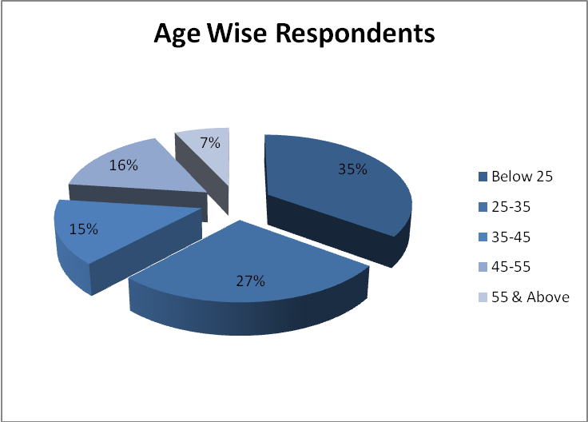

Interpretation:

From the above table, it can be seen that
- 35% of the women employees are below the age of 25 years.
- 27% of the women employees are between the age of 25-35 years.
- 15% of the women employees are between the age of 35-45 years.
- 16% of the women employees are between the age of 45-55 years.
- 7% of the women employees are between the age of 55years and above.

Inference:

- Majority (35%) of the women employees are below 25 years of age.

Experience Wise Respondents
Table No 4.2

Experience in yrs | No. of Respondents | Percentage | Cumulative Percentage
Below 5yrs | 45 | 45 | 45
5-10yrs | 27 | 27 | 72
10-15yrs | 15 | 15 | 87
15-20yrs | 6 | 6 | 93
20-25yrs | 6 | 6 | 99
Above 25 | 1 | 1 | 100
 | 100 | 100

Chart No 4.2

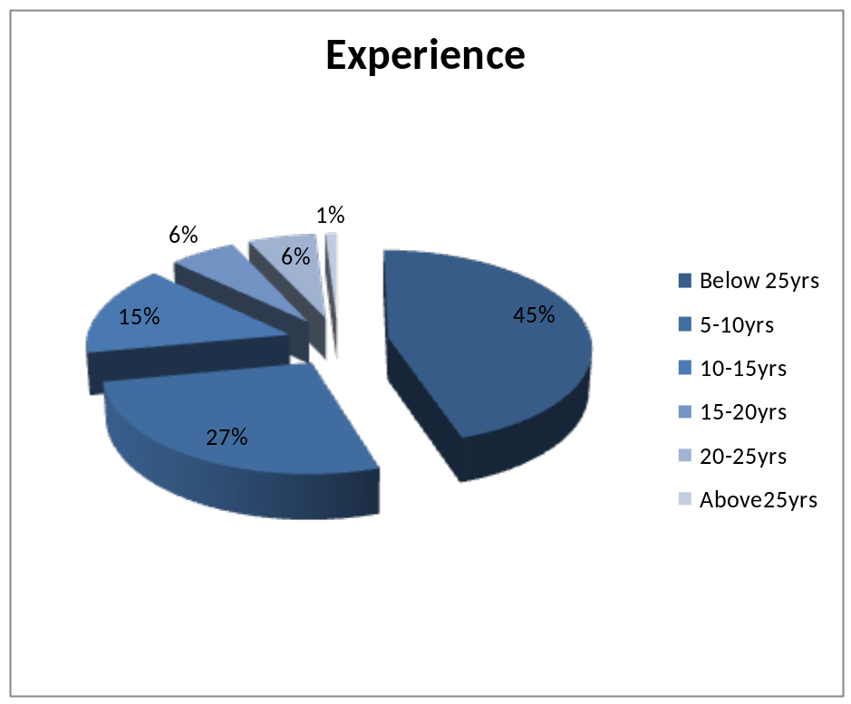

Interpretation:

From the above table it can be seen that
- 45% of the women respondents are below 5 years of experience.
- 27% of the women respondents are 5-10 years of experience.
- 15% of the women respondents are 10-15 years of experience.
- 6% of the women respondents are 15-20 years of experience.
- 6% of the women respondents are 20-25 years of experience.
- 1% of the women respondents are 25& above years of experience.

Inference:

- Majority (45%) of the respondents are below 5 years of experience.

Satisfactory Level On Periodical Health Check Up Respondents
Table No 4.3

Opinion | No. of Respondents | Percentage | Cumulative Percentage
Highly Satisfied | 43 | 43 | 43
Satisfied | 32 | 32 | 75
Satisfied Nor Dissatisfied | 16 | 16 | 91
Dissatisfied | 6 | 6 | 97
Highly Dissatisfied | 3 | 3 | 100
 | 100 | 100
 | 100 | 100

Chart No 4.3
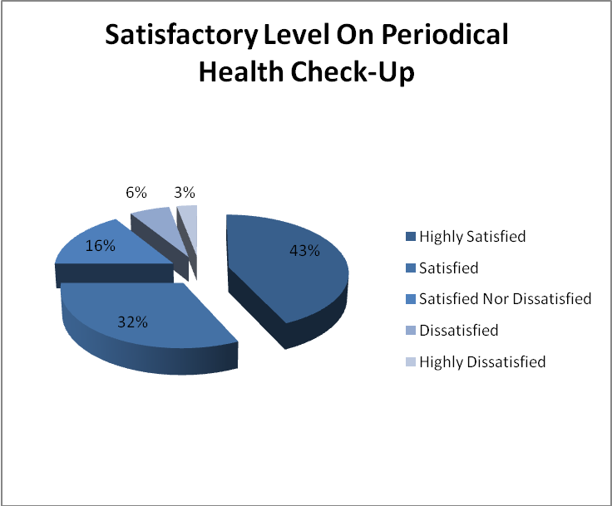

Interpretation:

From the above table, it can be seen that
- 42% of the women respondents are highly satisfied with the periodical health check-up for the women employees by the company.
- 32% of the women respondents are satisfied with the periodical health check-up for the women employees by the company.
- 16% of the women respondents are satisfied nor dissatisfied with the periodical health check-up for the women employees by the company.
- 6% of the women respondents are dissatisfied with the periodical health check-up for the women employees by the company.
- 3% of the women respondents are highly dissatisfied with the periodical health check-up for the women employees by the company.

Inference:

- Majority (42%) of the women respondents are highly satisfied with the periodical health check-up for the women employees by the company.

Satisfactory Level Towards Iron Tablet
Table No 4.4

Satisfactory Level | No. of Respondents | Percentage | Cumulative Percentage
Highly Satisfied | 50 | 50 | 50
Satisfied | 29 | 29 | 79
Satisfied Nor Dissatisfied | 13 | 13 | 92
Dissatisfied | 8 | 8 | 100
Highly Dissatisfied | 0 | 0 | 100
 | 100 | 100

Chart No 4.4

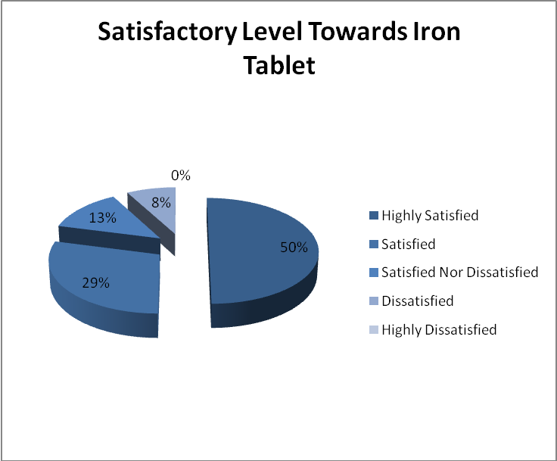

Interpretation:

From the above table, it can be seen that
- 50% of the women respondents are highly satisfied with the Iron tablet provided by the company.
- 29% of the women respondents are satisfied with the Iron tablet provided by the company.
- 13% of the respondents are neither satisfied nor dissatisfied with the Iron tablet provided by the company.
- 8% of the respondents are dissatisfied with the Iron tablet provided by the company.
- 0% of the respondents are highly dissatisfied with the Iron tablet provided by the company.

Inference:

- Majority (50%) of the respondents are highly satisfied with the Iron tablet provided by the company.

Satisfactory Level On First Aid Appliances
Table No 4.5

Satisfactory Level | No. of Respondents | Percentage | Cumulative Percentage
Highly Satisfied | 49 | 49 | 49
Satisfied | 29 | 29 | 78
Satisfied Nor Dissatisfied | 14 | 14 | 92
Dissatisfied | 7 | 7 | 99
Highly Dissatisfied | 1 | 1 | 100
 | 100 | 100

Chart No 4.5

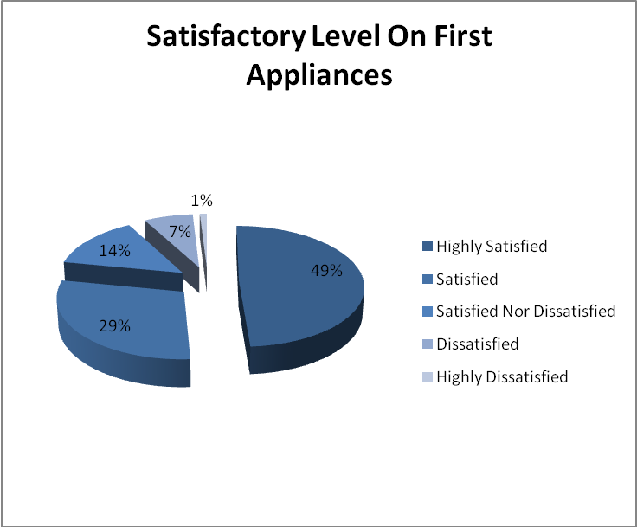

Interpretation:

From the above table, can be seen that
- 49% of the women respondents state that company providing first aid appliances to the employees are highly satisfied.
- 24% of the women respondents state that company providing first aid appliances to the employees are satisfied.
- 14% of the women respondents state that company providing first aid appliances to the employees are neither satisfied nor dissatisfied.
- 7% of the women respondents state that company providing first aid appliances to the employees are dissatisfied.
- 1% of the women respondents state that company providing first aid appliances to the employees are highly dissatisfied.

Inference:

- Majority (49%) of the women respondents state that company providing first aid appliances to the employees highly satisfied.

Satisfaction Level Towards Maternity benefits
Table No 4.6

Satisfactory Level | No. of Respondents | Percentage | Cumulative Percentage
Highly Satisfied | 48 | 48 | 48
Satisfied | 27 | 27 | 75
Satisfied Nor Dissatisfied | 18 | 18 | 93
Dissatisfied | 7 | 7 | 100
Highly Dissatisfied | 0 | 0 | 100
 | 100 | 100

Chart No 4.6

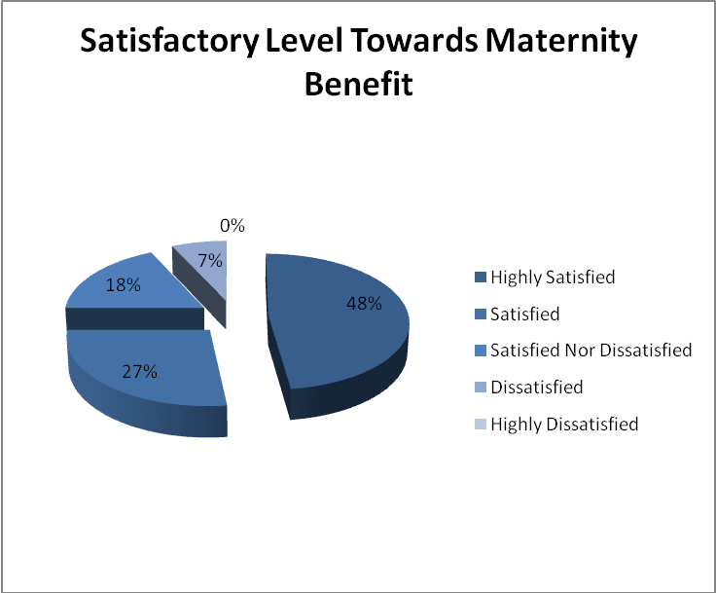

Interpretation:

From the above table, it can be seen that
- 48% of the women respondents are highly satisfied with the Maternity Benefits.
- 27% of the women respondents are satisfied with the Maternity Benefits.
- 18% of the women respondents are neither satisfied nor dissatisfied with the Maternity Benefits.
- 7% of the women respondents are dissatisfied with the Maternity Benefits.
- 0% of the women respondents are highly dissatisfied with the Maternity Benefits.

Inference:

- Majority 48% of the women respondents are highly satisfied with the Maternity Benefits.

Satisfactory Level On Incentives For Reducing Absenteeism
Table No 4.7

Satisfactory Level | No. of Respondents | Percentage | Cumulative Percentage
Highly Satisfied | 41 | 41 | 41
Satisfied | 29 | 29 | 70
Satisfied Nor Dissatisfied | 26 | 26 | 96
Dissatisfied | 3 | 3 | 99
Highly Dissatisfied | 1 | 1 | 100
 | 100 | 100

Chart No 4.7

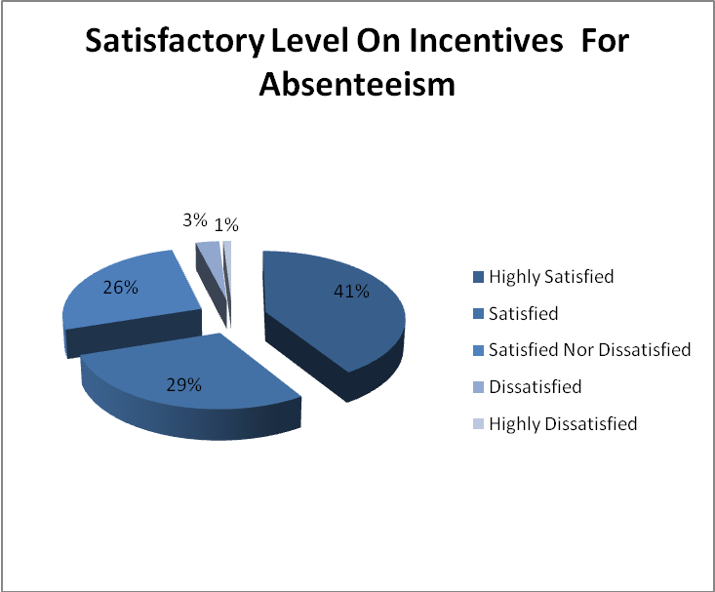

Interpretation:

From the above table, can be seen that
- 41% of the women respondents state that they are highly satisfied with the company providing incentives for reduction of absenteeism.
- 29% of the women respondents state that are satisfied with the company providing incentives for reduction of absenteeism.
- 26% of the women respondents state that are neither satisfied nor dissatisfied with the company providing incentives for reduction of absenteeism.
- 3% of the women respondents state that are dissatisfied with the company providing incentives for reduction of absenteeism.
- 1% of the women respondents state that are highly dissatisfied with the company providing incentives for reduction of absenteeism.

Inference:

- Majority 41% of the women respondents state that are highly satisfied with the company providing incentives for reduction of absenteeism.

Satisfactory Level Towards Transport Facilities
Table No 4.8

Satisfactory Level | No. of Respondents | Percentage | Cumulative Percentage
Highly Satisfied | 33 | 33 | 33
Satisfied | 35 | 35 | 68
Satisfied Nor Dissatisfied | 24 | 24 | 92
Dissatisfied | 6 | 6 | 98
Highly Dissatisfied | 2 | 2 | 100
 | 100 | 100

Chart No 4.8

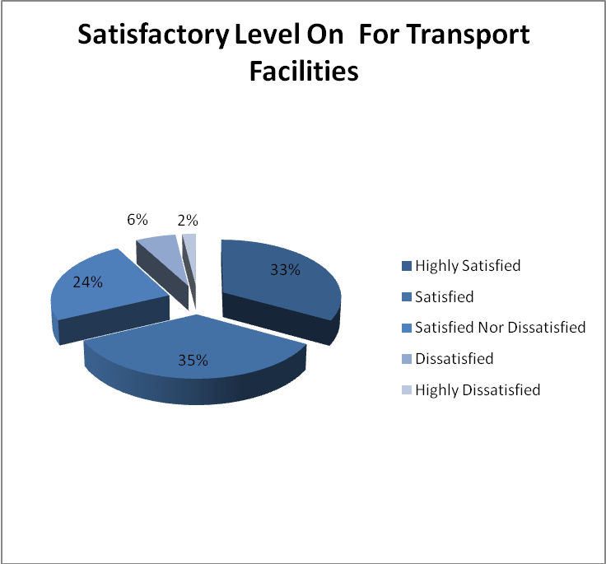

Interpretation:

From the above table, can be seen that
- 33% of the women employees are highly satisfied with the transport facilities are convenient to the employees.
- 35% of the women employees are satisfied with the transport facilities are convenient to employees.
- 24% of the women employees are neither satisfied nor dissatisfied with the transport facilities are convenient to the employees.
- 6% of the women employees are dissatisfied with the transport facilities are convenient to the employees.
- 2% of the women employees are highly dissatisfied with the transport facilities are convenient to the employees.

Inference:

- Majority 35% of the women employees are satisfied with the transport facilities are convenient to the employees.

Satisfactory Level Towards Canteen Hygiene
Table No 4.9

Satisfactory Level | No. of Respondents | Percentage | Cumulative Percentage
Highly Satisfied | 48 | 48 | 48
Satisfied | 29 | 29 | 77
Satisfied Nor Dissatisfied | 20 | 20 | 97
Dissatisfied | 3 | 3 | 100
Highly Dissatisfied | 0 | 0 | 100
 | 100 | 100

Chart No 4.9

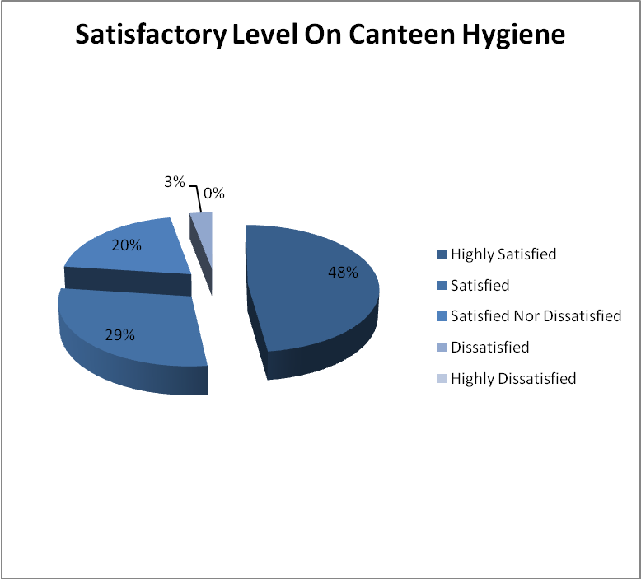

Interpretation:

From the above table, it can be seen that
- 48% of the women employees are highly satisfied with the canteen hygiene.
- 29% of the women employees are satisfied with the canteen hygiene.
- 20% of the women employees are satisfied nor dissatisfied with the canteen hygiene.
- 3% of the women employees are dissatisfied with the canteen hygiene.
- 0% of the women employees are highly dissatisfied with the canteen hygiene.

Inference:

- Majority (48%) of the women employees are highly satisfied with the canteen hygiene.

Satisfactory Level Towards Tables and Chairs in Canteen
Table No 4.10

Satisfactory Level | No. of Respondents | Percentage | Cumulative Percentage
Highly Satisfied | 46 | 46 | 46
Satisfied | 35 | 35 | 81
Satisfied Nor Dissatisfied | 14 | 14 | 95
Dissatisfied | 4 | 4 | 99
Highly Dissatisfied | 1 | 1 | 100
 | 100 | 100

Chart No 4.10

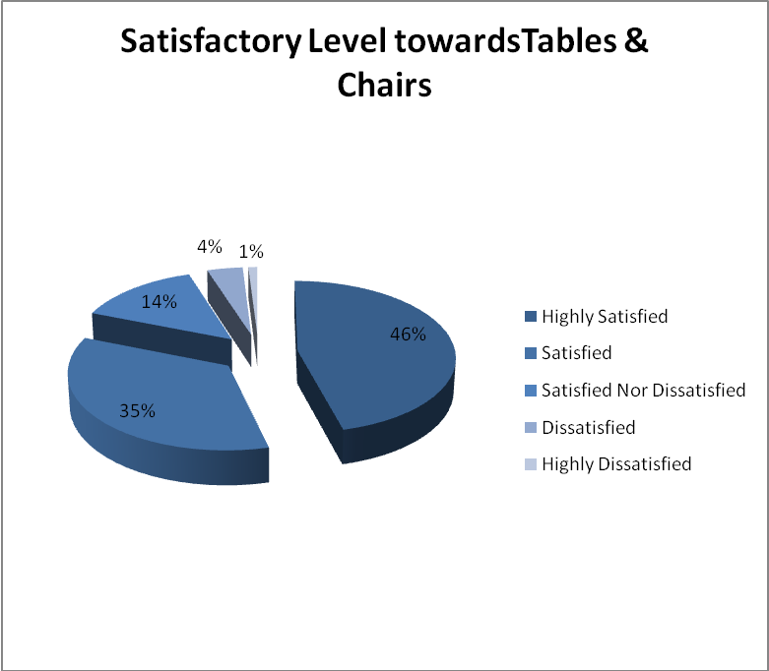

Interpretation:

From the above table, it can be seen that
- 46% of the women employees are highly satisfied with the company having adequate provision of tables and chairs in canteen.
- 35% of the women employees are satisfied with the company having adequate provision of tables and chairs in canteen.
- 14% of the women employees are neither satisfied nor dissatisfied with the company having adequate provision of tables and chairs in canteen.
- 4% of the women employees are dissatisfied with the company having adequate provision of tables and chairs in canteen.
- 1% of the women employees are highly dissatisfied with the company having adequate provision of tables and chairs in canteen.

Inference:

- Majority (46%) of the women employees are highly satisfied with the company having adequate provision of tables and chairs in canteen.

Satisfactory Level Towards Food Quality
Table No 4.11

Satisfactory Level | No. of Respondents | Percentage | Cumulative Percentage
Highly Satisfied | 40 | 40 | 40
Satisfied | 20 | 20 | 60
Satisfied Nor Dissatisfied | 25 | 25 | 85
Dissatisfied | 13 | 13 | 98
Highly Dissatisfied | 2 | 2 | 100
 | 100 | 100

Chart No 4.11

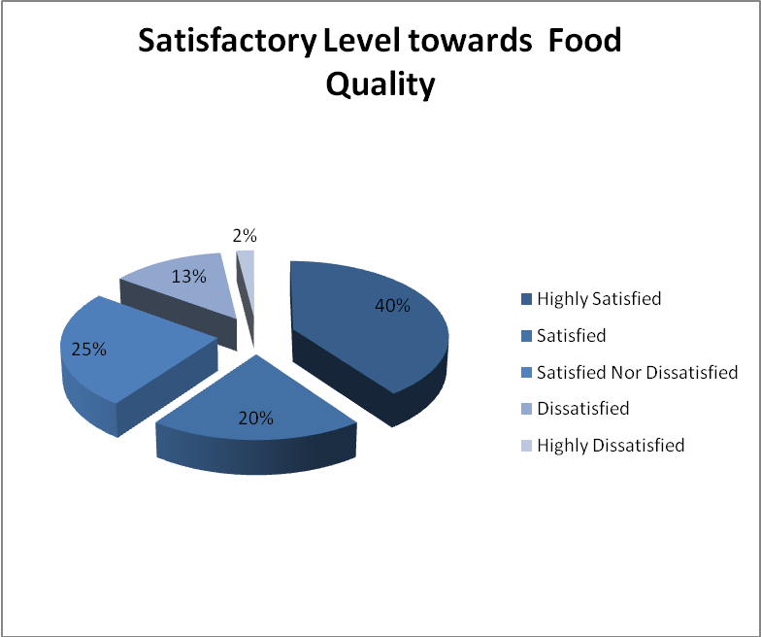

Interpretation:

From the above table, it can be seen that
- 40% of the women respondents are highly satisfied with the company providing good quality of food in canteen.
- 20% of the women respondents are satisfied with the company providing good quality of food in canteen.
- 25% of the women respondents are neither satisfied nor dissatisfied with the company providing good quality of food in canteen.
- 13% of the women respondents are dissatisfied with the company providing good quality food in canteen.
- 2% of the women respondents are highly dissatisfied with the company providing good quality food in canteen.

Inference:

- Majority (40%) of the women respondents are company providing good quality food in canteen.

Satisfactory Level Towards Break Timing
Table No 4.12

Satisfactory Level | No. of Respondents | Percentage | Cumulative Percentage
Highly Satisfied | 41 | 40 | 41
Satisfied | 18 | 18 | 59
Satisfied Nor Dissatisfied | 24 | 24 | 83
Dissatisfied | 15 | 15 | 98
Highly Dissatisfied | 2 | 2 | 100
 | 100 | 100

Chart No 4.12

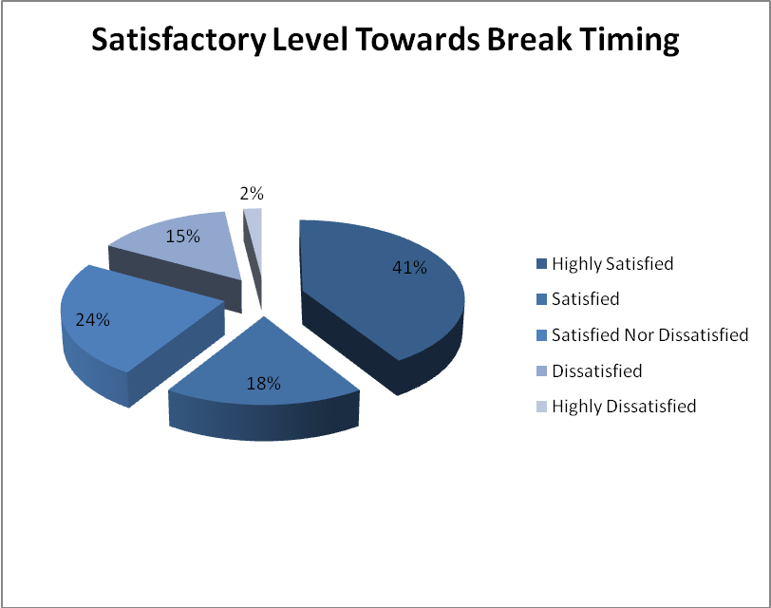

Interpretation:

From the above table, can be seen that
- 41% of the women respondents are highly satisfied with timing for Tea break and lunch is convenient.
- 18% of the women respondents are satisfied with timing for Tea break and lunch is convenient.
- 24% of the women respondents are neither satisfied nor dissatisfied with timing for Tea break and lunch is convenient.
- 15% of the women respondents are dissatisfied with timing for Tea break and lunch is convenient.
- 2% of the women respondents are highly dissatisfied with timing for Tea break and lunch is convenient.
Inference:

- 41% of the women respondents are highly satisfied with timing for Tea break and lunch is convenient.

Satisfaction level On Training Programmes
Table No 4.13

Satisfactory Level | No. of Respondents | Percentage | Cumulative Percentage
Highly Satisfied | 55 | 55 | 55
Satisfied | 32 | 32 | 82
Satisfied Nor Dissatisfied | 13 | 13 | 95
Dissatisfied | 5 | 5 | 100
Highly Dissatisfied | 0 | 0 | 100
 | 100 | 100

Chart No 4.13

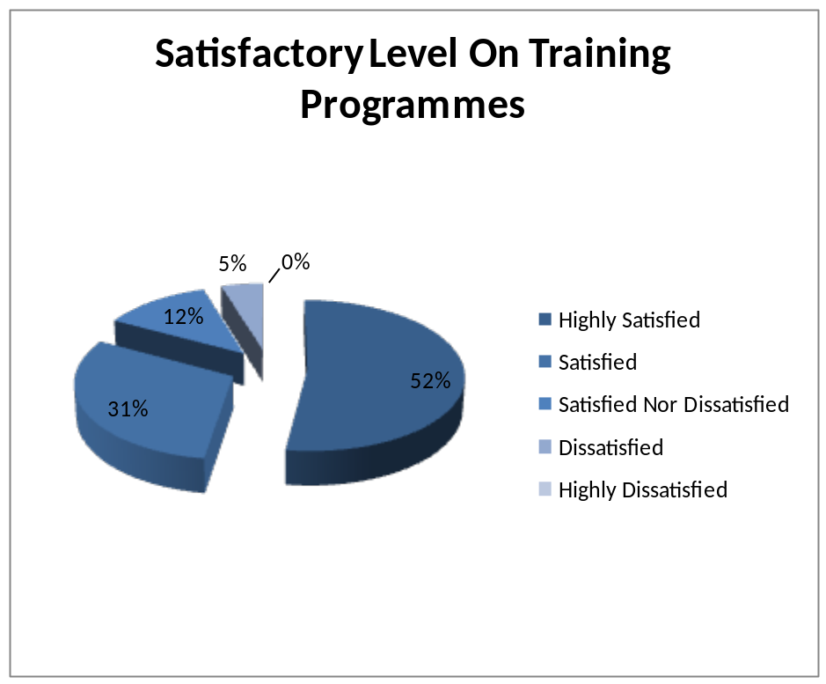

Interpretation:

From the above table, can be seen that
- 55% of the women respondents are highly satisfied with the training conducted for health and safety measures.
- 32% of the women respondents are satisfied with the training conducted for health and safety measures.
- 13% of the women respondents are neither satisfied nor dissatisfied with the training conducted for health and safety measures.
- 5% of the women respondents are dissatisfied with the training conducted for health and safety measures.
- 0% of the women respondents are highly dissatisfied with the training conducted for health and safety measures.

Inference:

- Majority (55%) of the women respondents are highly satisfied with the training conducted for health and safety measures.

Satisfaction level Towards Water Facilities
Table No 4.14

Satisfactory Level | No. of Respondents | Percentage | Cumulative Percentage
Highly Satisfied | 46 | 46 | 46
Satisfied | 29 | 29 | 75
Satisfied Nor Dissatisfied | 18 | 18 | 93
Dissatisfied | 7 | 7 | 100
Highly Dissatisfied | 0 | 0 | 100
 | 100 | 100

Chart No 4.14

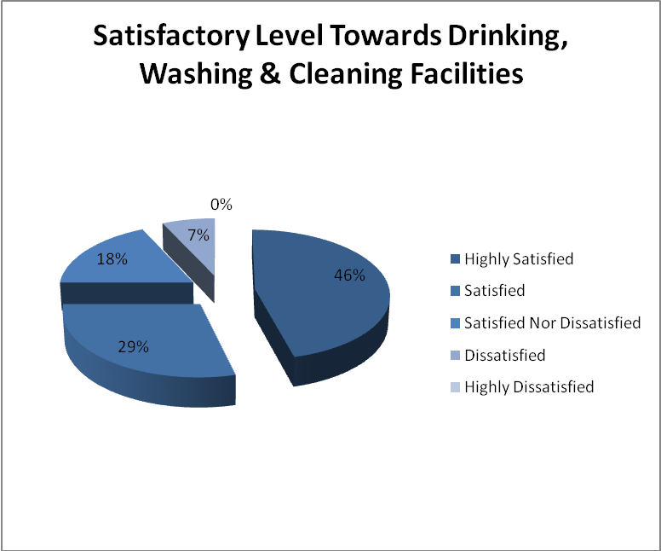

Interpretation:

From the above table, can be seen that
- 46% of the women respondents are highly satisfied with the drinking water, washing and cleaning facilities.
- 29% of the women respondents are satisfied with the drinking water, washing and cleaning facilities.
- 18% of the women respondents are neither satisfied nor dissatisfied with the drinking water, washing and cleaning facilities.
- 7% of the women respondents are dissatisfied with the drinking water, washing and cleaning facilities.
- 0% of the women respondents are highly dissatisfied with the drinking water, washing and cleaning facilities.

Inference:

- Majority 46% of the respondents are highly satisfied with the drinking water, washing and cleaning facilities provided by the company.

Satisfaction level towards Ventilation and Lighting
Table No 4.15

Satisfactory Level | No. of Respondents | Percentage | Cumulative Percentage
Highly Satisfied | 60 | 60 | 60
Satisfied | 18 | 18 | 78
Satisfied Nor Dissatisfied | 12 | 12 | 90
Dissatisfied | 10 | 10 | 100
Highly Dissatisfied | 0 | 0 | 100
 | 100 | 100

Chart No 4.15

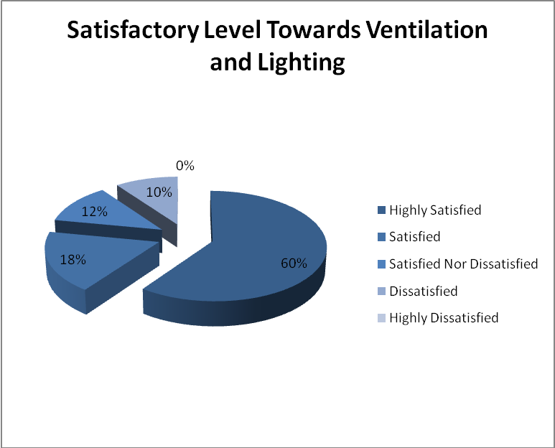

Interpretation:

From the above table, can be seen that
- 60% of the respondents are highly satisfied by ventilation and lighting facilities provided in the work place.
- 18% of the respondents are satisfied by ventilation and lighting facilities provided in the work place.
- 12% of the respondents are neither satisfied nor dissatisfied by ventilation and lighting facilities provided in the work place.
- 10% of the respondents are dissatisfied by ventilation and lighting facilities provided in the work place.
- 0% of the respondents are highly dissatisfied by ventilation and lighting facilities provided in the work place.

Inference:

- Majority 60% of the respondents are highly satisfied by ventilation and lighting facilities provided in the work place.

Satisfactory Level Towards Toilet Facilities
Table No 4.16

Satisfactory Level | No. of Respondents | Percentage | Cumulative Percentage
Highly Satisfied | 19 | 19 | 19
Satisfied | 26 | 26 | 45
Satisfied Nor Dissatisfied | 13 | 13 | 58
Dissatisfied | 30 | 30 | 88
Highly Dissatisfied | 12 | 12 | 100
 | 100 | 100

Chart No 4.16

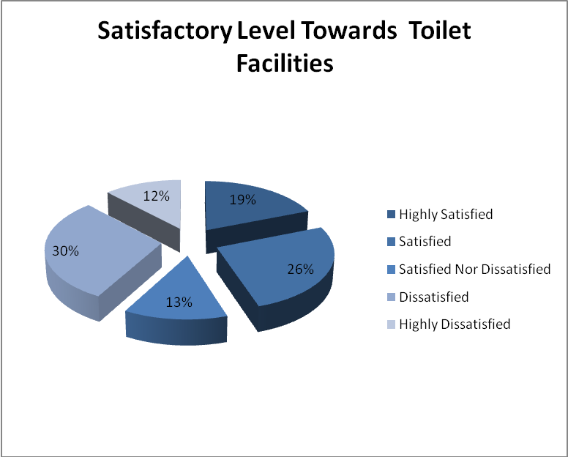

Interpretation:

From the above table, can be seen that
- 19% of the women respondents are highly satisfied with the toilet facilities provided by the company.
- 26% of the women respondents are satisfied with the toilet facilities provided by the company.
- 13% of the women respondents are neither satisfied nor dissatisfied with the toilet facilities provided by the company.
- 30% of the women respondents are dissatisfied with the toilet facilities provided by the company.
- 12% of the women respondents are highly dissatisfied with the toilet facilities provided by the company.

Inference:

- Majority (30%) of the women respondents are dissatisfied with the toilet facilities provided by the company.

Satisfactory Level Towards Festival Celebration
Table No 4.17

Satisfactory Level | No. of Respondents | Percentage | Cumulative Percentage
Highly Satisfied | 65 | 65 | 65
Satisfied | 20 | 20 | 85
Satisfied Nor Dissatisfied | 10 | 10 | 95
Dissatisfied | 4 | 4 | 99
Highly Dissatisfied | 1 | 1 | 100
 | 100 | 100

Chart No 4.17

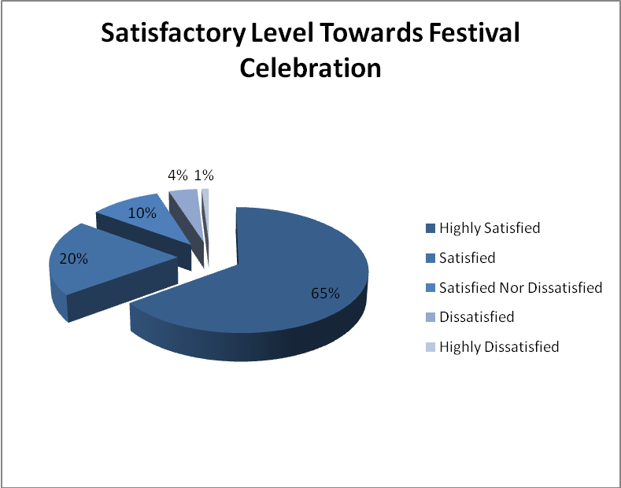

Interpretation:

From the above table, it can be seen that
- 65% of the women respondents are highly satisfied with the festival celebration in the company.
- 20% of the women respondents are satisfied with the festival celebration in the company.
- 10% of the women respondents are neither satisfied nor dissatisfied with the festival celebration in the company.
- 4% of the women respondents are dissatisfied with the festival celebration in the company.
- 1% of the women respondents are highly dissatisfied with the festival celebration in the company.

Inference:

- Majority 65% of the respondents are highly satisfied with the festival celebration in the company.

Satisfactory Level Towards Family Visit By Employer
Table No 4.18

Satisfactory Level | No. of Respondents | Percentage | Cumulative Percentage
Highly Satisfied | 44 | 44 | 44
Satisfied | 32 | 32 | 76
Satisfied Nor Dissatisfied | 18 | 18 | 94
Dissatisfied | 5 | 5 | 99
Highly Dissatisfied | 1 | 1 | 100
 | 100 | 100

Chart No 4.18

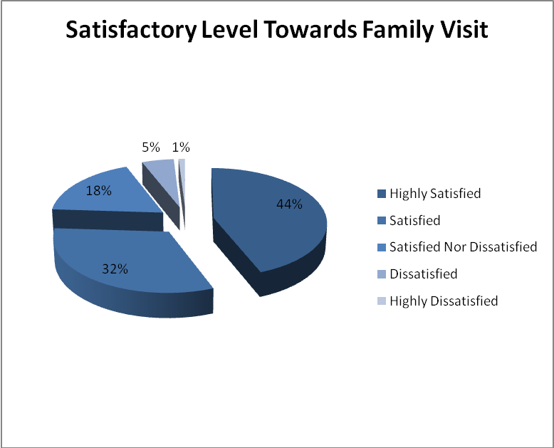

Interpretation:

From the above table, it can be seen
- 44% of the women respondents are highly satisfied with the family visit by the employer.
- 32% of the women respondents are satisfied with the family visit by the employer.
- 18% of the women respondents are neither satisfied nor dissatisfied with the family visit by the employer.
- 5% of the women respondents are dissatisfied with the family visit by the employer.
- 1% of the women respondents are highly dissatisfied with the family visit by the employer.

Inference:

- Majority (44%) % of the women respondents are highly satisfied with the family visit by the employer.

Satisfaction Level Towards Education Allowance
Table No 4.19

Satisfactory Level | No. of Respondents | Percentage | Cumulative Percentage
Highly Satisfied | 43 | 43 | 43
Satisfied | 18 | 18 | 61
Satisfied Nor Dissatisfied | 29 | 29 | 90
Dissatisfied | 8 | 8 | 98
Highly Dissatisfied | 2 | 2 | 100
 | 100 | 100

Chart No 4.19

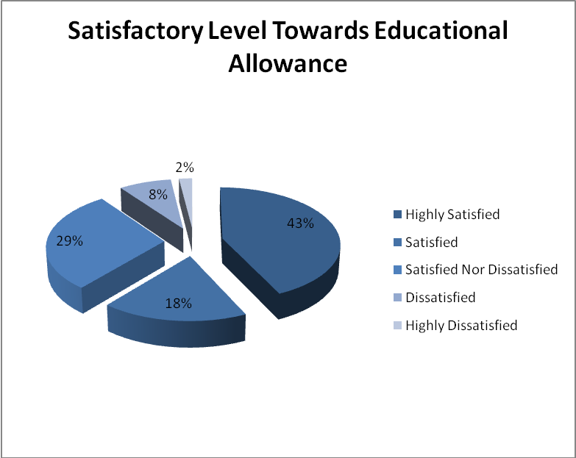

Interpretation:

From the above table, it can be seen that
- 43% of the respondents are highly satisfied with the education allowance provided to the employee’s children.
- 18% of the women respondents are satisfied with the education allowance provided to the employee’s children.
- 29% of the women respondents are neither satisfied nor dissatisfied with the education allowance provided to the employee’s children.
- 8% of the women respondents are dissatisfied with the education allowance provided to the employee’s children.
- 2% of the women respondents are highly dissatisfied with the education allowance provided to the employee’s children.

Inference:

- Majority (43%) of the women respondents are highly satisfied with the education allowance provided to the employee’s children.

Opinion Towards Crèche Facilities
Table No 4.20

Opinion | No. of Respondents | Percentage | Cumulative Percentage
Yes | 0 | 0 | 0
No | 100 | 100 | 100
 | 100 | 100

Chart No 4.20

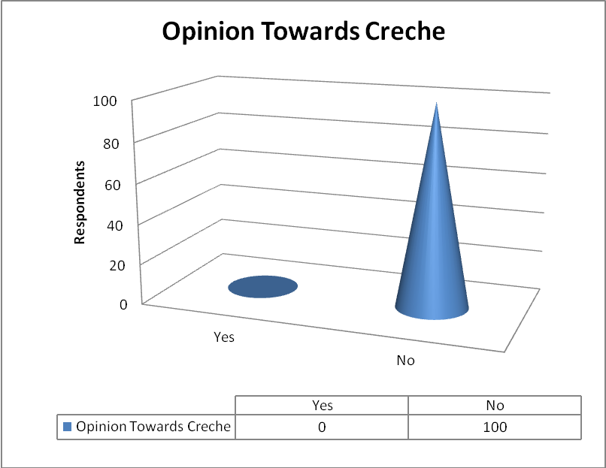

Interpretation:

From the above table, it can seen that
- 0% of the women respondents state that there is crèche facilities in the company.
- 100% of the women respondents state that there is no crèche facilities in the company.

Inference:

- Majority (100%) of the respondents states that there is no crèche facilities in the company.

Satisfactory Level Towards Service Award at Every year.
Table No 4.21

Satisfactory Level | No. of Respondents | Percentage | Cumulative Percentage
Highly Satisfied | 60 | 60 | 60
Satisfied | 25 | 25 | 85
Satisfied Nor Dissatisfied | 12 | 12 | 97
Dissatisfied | 3 | 3 | 100
Highly Dissatisfied | 0 | 0 | 100
 | 100 | 100

Chart No 4.21

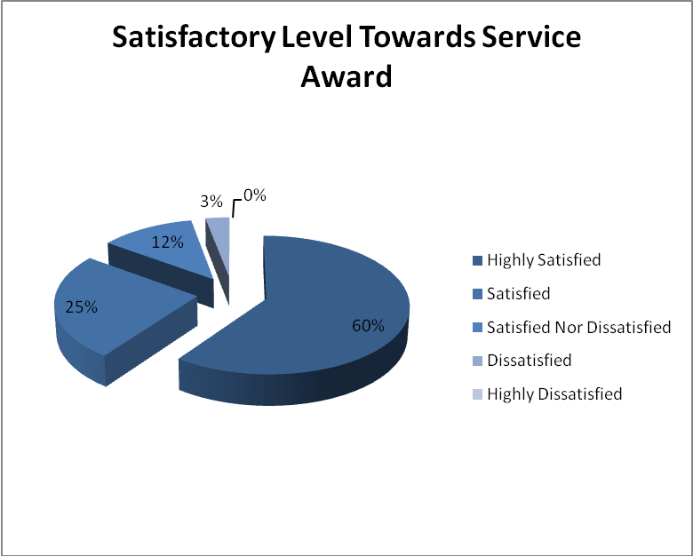

Interpretation:

From the above table, it can be seen that
- 60% of the women respondents are highly satisfied with the service award.
- 25% of the women respondents are satisfied with the service award.
- 12% of the women respondents are neither satisfied nor dissatisfied with the service award.
- 3% of the women respondents are dissatisfied with the service award.
- 0% of the women respondents are highly satisfied with the service award.

Inference:

- Majority (60%) of the women respondents are highly satisfied with the service award.

Satisfactory Level Towards Holiday Trips
Table No 4.22

Satisfactory Level | No. of Respondents | Percentage | Cumulative Percentage
Highly Satisfied | 51 | 51 | 51
Satisfied | 32 | 32 | 83
Satisfied Nor Dissatisfied | 12 | 12 | 95
Dissatisfied | 3 | 3 | 98
Highly Dissatisfied | 2 | 2 | 100
 | 100 | 100

Chart No 4.22

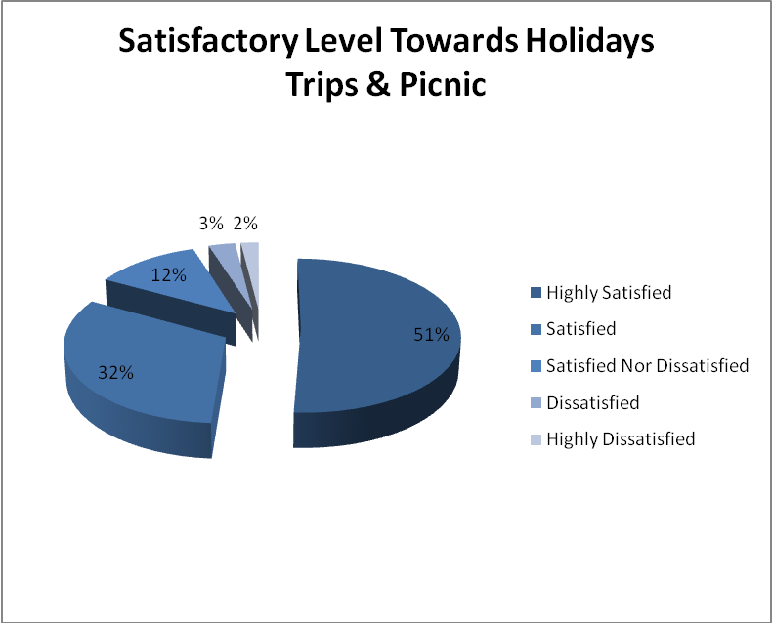

Interpretation:

From the above table, can be seen that
- 51% of the women respondents are highly satisfied with the holiday trips and picnic provided by the company.
- 32% of the women respondents are satisfied with the holiday trips and picnic provided by the company.
- 12% of the women respondents are neither satisfied nor satisfied with the holiday trips and picnic provided by the company.
- 3% of the women respondents are dissatisfied with the holiday trips and picnic provided by the company.
- 2% of the women respondents are highly satisfied with the holiday trips and picnic provided by the company.

Inference:

- Majority (51%) of the women respondents are satisfied with the holiday trips and picnic provided by the company.

Satisfaction Level Towards Welfare Activities
Table No 4.23

Satisfactory Level | No. of Respondents | Percentage | Cumulative Percentage
Highly Satisfied | 68 | 68 | 68
Satisfied | 21 | 21 | 89
Satisfied Nor Dissatisfied | 7 | 7 | 96
Dissatisfied | 4 | 4 | 100
Highly Dissatisfied | 0 | 0 | 100
 | 100 | 100

Chart No 4.23

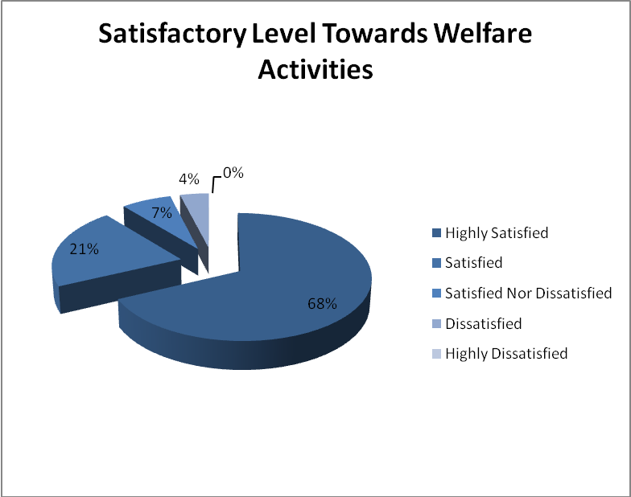

Interpretation:

From the above table, it can be seen that
- 68% of the women respondents are highly satisfied with the welfare activities provided by the employer.
- 21% of the women respondents are satisfied with the welfare activities provided by the employer.
- 7% of the women respondents are neither satisfied nor dissatisfied with the welfare activities provided by the employer.
- 4% of the women respondents are dissatisfied with the welfare activities provided by the employer.
- 0% of the women respondents are highly dissatisfied with the welfare activities provided by the employer.

Inference:

- Majority (68%) of the women respondents are highly satisfied with the welfare activities provided by the employer.

Opinion About Family Disputes Counselling
Table No 4.24

Opinion | No. of Respondents | Percentage | Cumulative Percentage
Yes | 37 | 37 | 37
No | 63 | 63 | 100
 | 100 | 100

Chart No 4.24

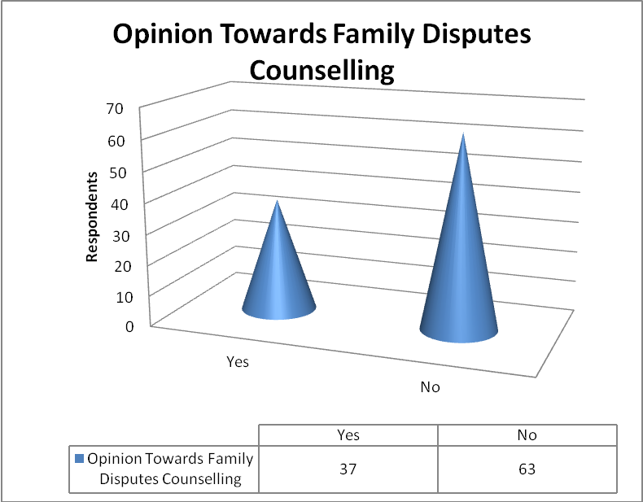

Interpretation:
From the above table, it can be seen that
- 37% of the respondent s state that there is family disputes counselling in the company.
- 63% of the respondents state that there is no family disputes counselling in the company.

Inference:
- Majority 63% of the respondents state that there is no family disputes counselling in the company.

Satisfactory Level On Improvement For Welfare Activities
Table No 4.25

Satisfactory Level | No. of Respondents | Percentage | Cumulative Percentage
Highly Satisfied | 66 | 66 | 68
Satisfied | 23 | 23 | 89
Satisfied Nor Dissatisfied | 4 | 4 | 93
Dissatisfied | 7 | 7 | 100
Highly Dissatisfied | 0 | 0 | 100
 | 100 | 100

Chart No 4.25

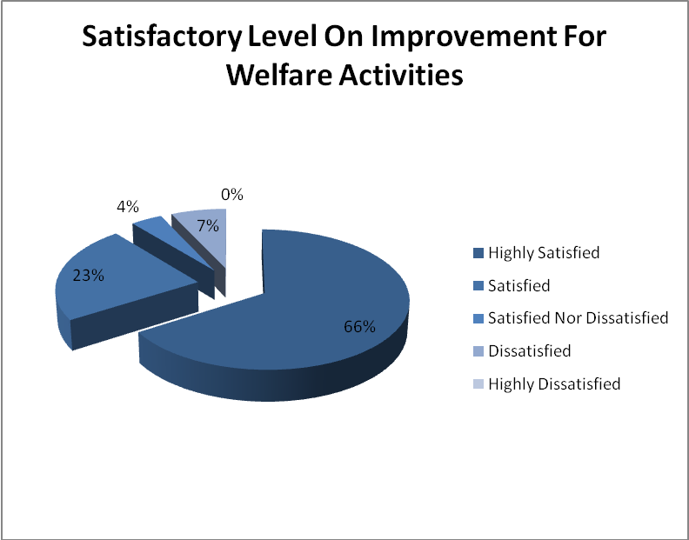

Interpretation:

From the above table, it can be seen that
- 66 % of the women respondents are highly satisfied with the improvement for the welfare activities.
- 23% of the women respondents are satisfied with the improvement for the welfare activities.
- 4% of the women respondents are neither satisfied nor dissatisfied with the improvement for the welfare activities.
- 7% of the women respondents are dissatisfied with the improvement for the welfare activities.
- 0% of the women respondents are highly dissatisfied with the improvement for the welfare activities.

Inference:

- Majority 65% of the respondent states that there is need to improve the welfare activities in the company.

4.26 Chi – Square test

Formulae
∑ = (O ᵢ - Eᵢ) ᶺ 2 ̸ Eᵢ

4.26 (a) SATISFACTORY LEVEL TOWARDS MATERNITY BENEFIT WOMEN EMPLOYEES

O ᵢ | Eᵢ | ( O ᵢ - Eᵢ )ᶺ2 | ∑ = ( O ᵢ - Eᵢ )ᶺ2 ̸ Eᵢ
48 | 20 | 784 | 39.2
27 | 20 | 49 | 2.45
18 | 20 | 4 | 0.2
7 | 20 | 169 | 8.45
0 | 20 | 400 | 20
 |  |  | 70.3

Data in brackets shows Expected Frequency

Hypothesis :

H₀: There is no satisfaction among women employees about the maternity benefit provided by the company.
H₁: There is satisfaction among women employees about the maternity benefit provided by the company.

Formulae:

χ² = Σ ( O - E )² / E

Degree of freedom = 4

Calculated value of χ² = 70.3

Table value of χ² at 0.05 = 9.488

Conclusion:

Calculated χ² < the tabulated χ², < so that we accept H₀, So, we conclude that there is no significance satisfaction difference among women employees about the maternity benefit provided by the company.

Chi – Square test

4.26 (b) SATISFACTORY LEVEL TOWARDS CLEANING FACILITIES AND ADEQUATE PROVISION OF VENTILATION AND LIGHTING

O ᵢ | Eᵢ | ( O ᵢ - Eᵢ )ᶺ2 | ∑ = ( O ᵢ - Eᵢ )ᶺ2 ̸ Eᵢ
46 | 60 | 196 | 3.26
29 | 18 | 121 | 6.72
18 | 12 | 36 | 3
7 | 10 | 9 | 0.9
0 | 0 | 0 | 0
 |  |  | 13.88

Data in brackets shows Expected Frequency

Hypothesis:

H₀: There is no difference between the cleaning facilities and adequate provision of ventilation and lightning in work place.

H₁: There is difference between the cleaning facilities and adequate provision of ventilation and lightning in work place.
Formulas:

χ² = Σ (O-E)² / E

Degree of freedom = 4
Calculated value of χ² = 108.4
Table value of χ² at 0.05 = 9.488

Conclusion:

Calculated χ² < the tabulated χ², < so that we accept H₀, So, we conclude that there is no significance difference between the cleaning facilities and adequate provision of ventilation and lightning in work place.

4.27 WEIGHTAGE AVERAGE METHOD

4.27 (a) EMPLOYEES SATISFACTION LEVEL TOWARDS TRAINING PROGRAMMES

Satisfactory Level | No. of Respondents | Weightage
Highly Satisfied | 55 | 5
Satisfied | 32 | 4
Neither Satisfied nor dissatisfied | 13 | 3
Dissatisfied | 5 | 2
Highly Dissatisfied | 0 | 1
 | 100

55*5+32*4+13*3+5*2+0*1 = 452
Average = Total value
No. of respondents
= 452
100
= 4.52

INFERENCE:
The average value is 4.52. It is clear that employees are satisfied with the food provided by the company.

4.28 ANOVA
One Way ANOVA

4.28 (a) SATISFACTORY LEVEL TOWARDS THE WELFARE ACTIVITIES TOWARDS EXPERIENCE

Frequency Table:

Factor | Highly  Satisfied | Satisfied | Neither  Satisfied  Nor Dissatisfied | Dissatisfied | Highly  Dissatisfied | Total
Below 10 | 42 | 9 | 3 | 0 | 0 | 54
10-20 | 16 | 11 | 4 | 3 | 0 | 34
20-30 | 9 | 0 | 0 | 0 | 0 | 10
Above 30 | 1 | 1 | 0 | 1 | 0 | 2
 | 68 | 21 | 7 | 4 | 0 | 100

Hypothesis:

H₀: There is no difference between the experience and satisfaction level towards the welfare activities of the women employees.

H₁: There is difference between the experience and satisfaction level the welfare activities employees.

Step 1:
To find correction factor
T = ΣX1+ΣX2+ΣX3+ΣX4+ΣX5
= 54+34+10+2+0
= 100
N = Total no. of items = 20
CF=T²/N
= 100² / 20=10000 / 20
=500
Step 2:
Sum of square of deviations for total variance=square of all items – C.F
= (ΣX1²/n+ΣX2²/n+ΣX3²/n+ΣX4²/n+ΣX5²/n)-C.F
= (68²/4+21²/4+7²/4+4²/4+0²/4)-500
= (1156+110.5+12.25+4+0)-500
= 1282.5-500
= 782.5
Step 3:
Sum of square of deviations between columns
= (ΣY1²/n+ΣY2²/n+ΣY3²/n+ΣY4²/n+ΣY5²/n)-C.F
= (54²/4+34²/4+10²/4+2²/4+0²/4)-500
= (583.2+231.2+50+0.8+0)-500
= 865.2-500
= 365.2
Degrees of freedom = 5-1=4
Step 4:
Sum of squares of deviation of residual variance = Sum of square of deviation for total variance – Sum of squares of deviation between column
= 782.5-365.2
= 417.3
F = Variance between column/Variance between Residual
= 91.3 / 52.31=1.74
Tabulated value of F test for VI and V2 = 3.8378

ANOVA TABLE

Sources of  Variance | Sum of squares of  deviation | Degrees of  freedom | Mean squares of  Deviation
Between Experience | 365.2 | 5-1=4 | 365.2 / 4 = 91.3
Residual | 419.5 | 4+5=8 | 419.5 / 8 = 52.32

Result:
Since the calculated value is < than the tabulated value, so that we accept H_{0,} So, we conclude that there is no difference between the experience and satisfaction level towards the welfare activities among the women employees.

CHAPTER-5

CONCLUSION

FINDINGS

  - FINDINGS

- Around 35% of the women employees are below the age of 30
- Around 45% of the women employees are having below 5 years experience
- Around 43% of the women employees feels that the company providing periodical health check up to the employees
- Around 50% of the women employees are highly satisfied with the iron tablet provided by the company.
- Around 49% of the women employees are highly satisfied with the first aid appliances provided by the company.
- Almost 48% of the women employees are highly satisfied with the maternity benefit given from the company.
- Almost 41% of the women employees are highly satisfied with incentives for reduction of absenteeism provided by the company.
- Around 35% of the women employees are satisfied with the transport facilities provided by the company.
- Almost 48% of the women employees are highly satisfied with the canteen hygiene.
- Almost 40% of the women employees are highly satisfied with the quality and items in canteen.
- Almost 46% of the women employees are highly satisfied with the chairs and tables in the canteen.
- Almost 41% of the women employees are highly satisfied with the break time provided by the company.
- Almost 55% of the women employees are highly satisfied with the training programmes for safety and health measures.
- Almost 46% of the women employees are highly satisfied towards drinking water, washing and cleaning facilities.
- Almost 60% of the women employees are highly satisfied towards with the adequate provision of the ventilation and lighting in work place.
- Almost 55% of the women employees are highly satisfied with the toilet facilities in the company.
- Almost 65% of the women employees are highly satisfied with the festival celebration programmes conducted by the company.
- Almost 44% of the women employees are highly satisfied with the employer visit.
- Almost 43% of the women employees are highly satisfied with the education allowance for the employees children.
- All women employee states that there is no crèche in the company.
- Almost 60% of the women employees are highly satisfied with service award from the company.
- Almost 51% of the women employees are highly satisfied with holiday trips and picnic from the company.
- Almost 68% of the women employees are highly satisfied with the welfare activities in the company.
- Almost 63% of the women employees are family disputes counseling.
- Almost 66% of the women employees are highly satisfied with the improvement in the welfare measures.

5.1 (a) Findings of Hypothesis Testing

- We conclude that there is significance satisfaction difference among the women employees about the maternity benefit provided by the company.

- We conclude that there is no significance difference between the department and the adequate provision of ventilation and lighting in work place provided by the company.

- We conclude that there is no significance difference between the experience and satisfaction level towards the welfare activities among the women employees.

SUGGESTIONS

5.2 SUGGESTIONS

From the study, I could suggest that the company should provide crèche in the company premises which help the women employees work with comfortable. The company should provide family disputes counseling for the employees. The company should provide welfare programmes and should train the employees whenever needed. The company should provide good toilet facilities and wash room facilities. They can provide more transport and good quality food in the company. Can give more incentives to reduce absenteeism. I could suggest that company should take immediate action for all the necessary needs.

CONCLUSION

5.3 CONCLUSION

The study entitled, “A STUDY ON WOMEN EMPLOYEES SATISFACTION TOWARDS HEALTH AND WELFARE MEASURES” was conducted with the chief objective to identify the satisfaction of the employees towards health and welfare schemes provided by the company. From the analysis of the primary data and the major findings, it can be concluded that the welfare measures schemes by PKAL company for motivating its employees are highly satisfactory with respect to the following aspect:
Medical facilities
Company’s provision for transport
Time provided for having food
Working environment facilities
Provision for educational allowance
Provision of iron tablet
It is observed that if the company providing transport facilities, service award, iron tablet, periodical health checkup and incentives to reduce the absenteeism for the women employees get highly satisfied and they do their job well.
During these three month of time I was able to interact with different people in the organization and know the functioning of the HR department. It helped me in getting a practical insight on the various HR concepts and in depth I was able to learn about the performance appraisal system which in turn aided me in applying it to my study.

BIBLIOGRAPHY

5.4 BIBLIOGRAPHY

Books
Vijay Ashdir – Management of Industrial Relations, Kalyani publishers,New Delhi Forat Edition-1993-1994
CR.Kothari - Research methodology, Methods & Techniques, New age International Publishers, revised 2nd edition 2004
C.B.Mamoria -Personnel Management, Himalaya Publishing House, Mumbai, Edition-1994
Panneer Selvam_Statistics for management, Sultan chand & sons, revised 3rd edition 2005.
Journals
Henson (1983)-Anticipatory Evaluation In HRD Programming, Employees Welfare Measures 37,5,89-94
Jones (1986)-Evaluating Management, Welfare measures in Australia, 13,2,20-22
Websites
www.preethi.in
www.google.com

Appendix

QUESTIONNAIRE

5.5 Questionnaire

Preethi Kitchen Appliances Private Ltd. Chennai

Project study on satisfactory level of women employee towards health and welfare measures
Name of the Project Trainee: Isabel Dinu Sulega L
Date:

Personal data
Name (optional) :
Age : below 30 30-40 40-50 above 50
Experience : below 5 05-10 10-15 above 15

Medical facilities
1. Do your company provide any periodical health check-up to you and your family members?
Highly Satisfied Satisfied Satisfied nor Dissatisfied
Dissatisfied Highly Dissatisfied
2. Are you satisfied with iron tablet given for your health?
Highly Satisfied Satisfied Satisfied nor Dissatisfied
Dissatisfied Highly Dissatisfied
3. Is the company maintaining First Aid appliances in work places?
Highly Satisfied Satisfied Satisfied nor Dissatisfied
Dissatisfied Highly Dissatisfied

Monetary benefits
4. How you value the maternity benefit given by the employer?
Highly Satisfied Satisfied Satisfied nor Dissatisfied
Dissatisfied Highly Dissatisfied
5. Whether the company providing any incentives to reduce the absenteeism?
Highly Satisfied Satisfied Satisfied nor Dissatisfied
Dissatisfied Highly Dissatisfied

Transport facilities
6. Whether transport facilities are convenient to employees?
Highly satisfied Satisfied Satisfied nor Dissatisfied
Dissatisfied Highly Dissatisfied

Canteen facilities
7. Whether the canteen is hygiene?
Highly satisfied Satisfied Satisfied nor Dissatisfied
Dissatisfied Highly Dissatisfied
8. How is the quality of food items in the canteen?
Highly satisfied Satisfied Satisfied nor Dissatisfied
Dissatisfied Highly Dissatisfied
9. Is there adequate provision of tables and chairs in company?
Highly satisfied Satisfied Satisfied nor Dissatisfied
Dissatisfied Highly Dissatisfied
10. Do you feel convenient with the timing for Breakfast/Tea break/lunch for your work?
Highly satisfied Satisfied Satisfied nor Dissatisfied
Dissatisfied Highly Dissatisfied

Factory welfares
11. How you value the training programmes for safety and health measures provided in your company?
Highly Satisfied Satisfied Satisfied nor Dissatisfied
Dissatisfied Highly Dissatisfied
12. How you value the drinking water and cleaning facilities provided by your company?
Highly Satisfied Satisfied Satisfied nor Dissatisfied
Dissatisfied Highly Dissatisfied
13. How you value the ventilation and lighting facilities in your work place?
Highly Satisfied Satisfied Satisfied nor Dissatisfied
Dissatisfied Highly dissatisfied
14. Do your company provide sufficient Toilet facilities in your work place?
Highly Satisfied Satisfied Satisfied nor Dissatisfied
Dissatisfied Highly dissatisfied

Family welfare programmes
15. How you value the festival Celebration in your company?
Highly satisfied Satisfied Satisfied nor Dissatisfied Dissatisfied Highly Dissatisfied
16. Do the employer visit you and your family at your doorstep?
Highly satisfied Satisfied Satisfied nor Dissatisfied Dissatisfied Highly Dissatisfied

Educational facilities
17. How you value the educational allowance given to your children?
Highly satisfied Satisfied Satisfied nor Dissatisfied
Dissatisfied Highly Dissatisfied
18. Do your company provide crèche for your children?
Yes No

Other measures
19. Are you satisfied with service award for employees at every year?
Highly satisfied Satisfied Satisfied nor Dissatisfied
Dissatisfied Highly Dissatisfied
20. What is the satisfactory level towards the holiday trips and picnic provided by the company ?
Highly satisfied Satisfied Satisfied nor Dissatisfied
Dissatisfied Highly Dissatisfied
21. What is your all over satisfaction towards the welfare activities?
Highly satisfied Satisfied Satisfied nor Dissatisfied
Dissatisfied Highly Dissatisfied
22. Do they provide counselling for family disputes of the employee?
Yes No
23. Are you satisfied with the further improvement in welfare measures in the organization?
Highly satisfied Satisfied Satisfied nor Dissatisfied
Dissatisfied Highly Dissatisfied

